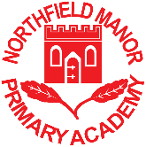

Mr T Hull: Head Teacher
Swarthmore Road, Selly Oak, Birmingham, B29 4JT
Telephone: 0121 675 2489

16th January 2024

Dear Parents and Carers,

Year 3 ‘Ancient Egypt’ Workshop

This term we are learning about ‘Ancient Egypt’. To support the children in their learning we have arranged for an engaging and informative workshop to be delivered by Queen Nefertiti (Tutankahmun’s mother). The workshop will take place in school on Monday 11th March 2024.

During the workshop, the children will:

- Learn about the tomb of Tutankhamun and its discoverer, Howard Carter.
- Create Egyptian jewellery.
- Use drama to create scenes about farming, nobility, scribes, afterlife, and mummification.
- Create drama scenes about the different Egyptian gods and their perceived powers.
- Explore how important myths are to civilisations and write their own myth.

The full cost of this workshop is £9.16 per child. Please make payment on Parent Pay by Wednesday 6th March 2024 at the latest. This letter should be kept for your future reference.

Yours faithfully

Mrs Vryaparj and Miss Cai
Year 3 Teachers

Email: enquiry@northfieldmanoracademy.org.uk
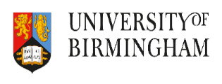
Website: www.northfieldmanoracademy.org.uk

