Year 4 Pack 2

Wednesday 18th January – Friday 21st January 2022

READING Tuesday 18th January 2022 – ‘The Hare and the Tortoise’
Activity 1 – Reading
Read the first section of ‘The tortoise and the Hare’ below:
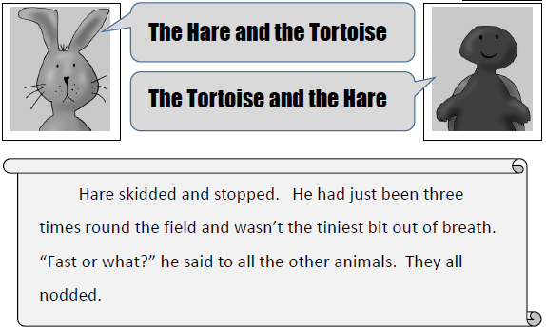

Activity 2 – Questions:
- At the beginning, it says: Hare skidded and stopped.
What does this mean? Tick one.
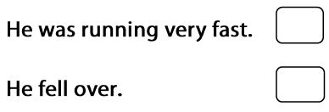

- All the other animals agreed that the hare was fast. Find and copy the phrase that shows you this.
________________________________________________________

- ‘He wasn’t the tiniest bit out of breath’. What does this phrase show you about how the hare is feeling after running?

________________________________________________________

- Hare says ‘Fast or What?’ to the other animals. How is he acting here?

WRITING Tuesday 18th January 2022 – Inverted commas in direct speech
Based on your writing over the last half term, we will be looking at a range of areas in our punctuation and grammar that will improve our writing and build your independence in creating exciting sentences this week and over the next half term. Today we will be looking at inverted commas.

What are inverted commas?
Scan the QR code or follow the link to find out more about inverted commas from the Oak National Academy.
https://classroom.thenational.academy/lessons/to-practise-speech-with-punctuation-68rp8e?step=1&activity=video

When you are writing, inverted commas (also called speech marks) go before and after any words that a character or person says.

For example: "I'm hungry," complained Goldilocks.

‘I’m hungry’ are the words that Goldilocks says out loud (also called direct speech), so the inverted commas go at the start and end of those words, with either a comma, exclamation mark or question mark before the second inverted comma. (, ! ?)

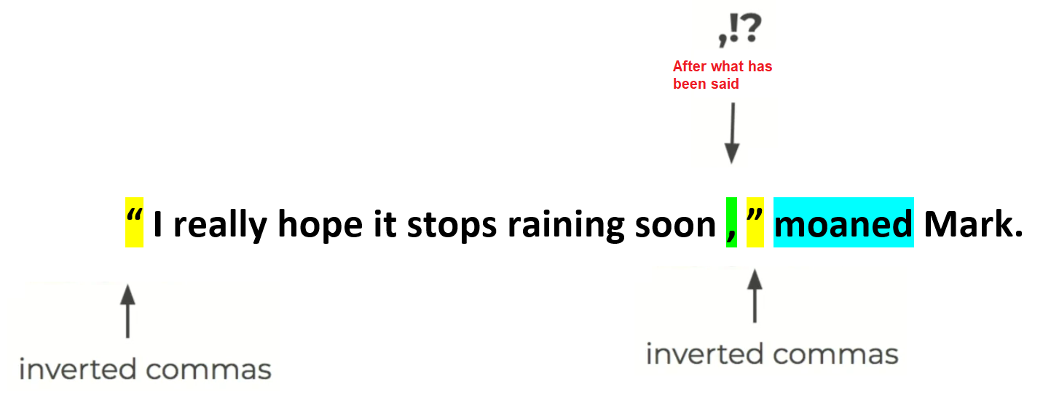
TASK 1 – Synonyms for said:
We use inverted commas for when people are speaking, but it can be very boring when we keep using the word ‘said’. How many different synonyms (words that mean the same or are similar) can you come up with? Two examples have been done for you:
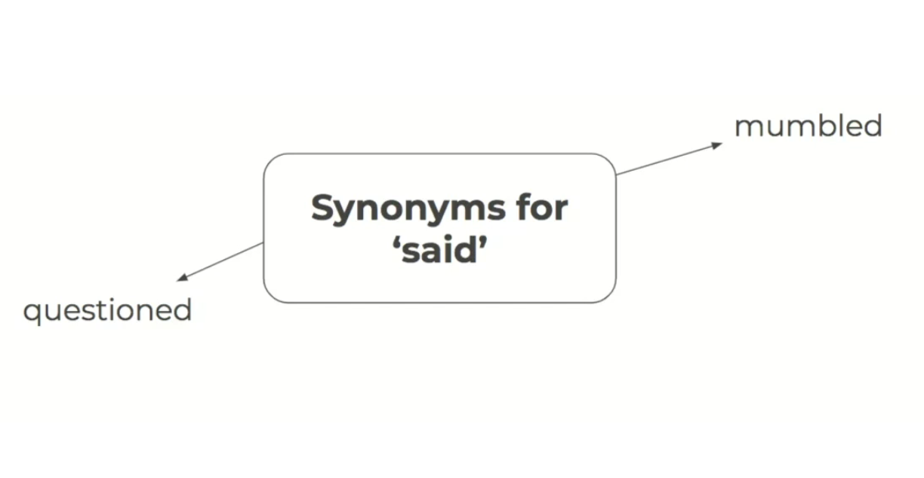
TASK 2 – Adding inverted commas
Below are some sentences with the inverted commas missing. For each sentence, underline the section that is being spoken and include the inverted commas into the correct place. The first two have been done for you.

- “ What’s for dinner dad? ” Jacinda asked.
- The witch looked at her sisters and asked, “ When will we three meet again? ”
- The mouse looked at the fox and whispered, Please don’t eat me.
- I’m stuck! Shouted Sam as he held up his hands.
- We won! We won! Screamed the boys as the final whistle blew.
- John, can you hold this? asked the sweet old lady.
- Be careful in the snow, it is really slippy out there, said her father.
- The policeman asked, Can I see your licence please?
- The teacher stood up and replied, Make sure you have checked your answers children.
TASK 3 – Inserting missing punctuation:
Mr Jenkins and Miss Schweizer have forgotten to include inverted commas and full stops in their writing below. Read the section carefully and add the inverted commas and full stops into the correct places.

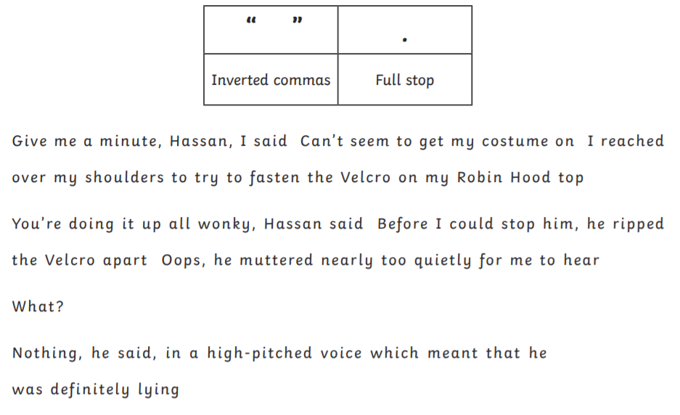
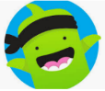
Take a photograph of your sentences using inverted commas for speech and upload them onto Dojo so that we can share these with the class.

MATHS – Tuesday 18th January 2022 – Number and Place Value
STARTER:
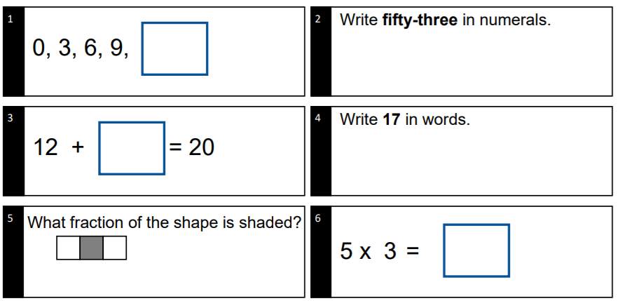

MAIN ACTIVITY:
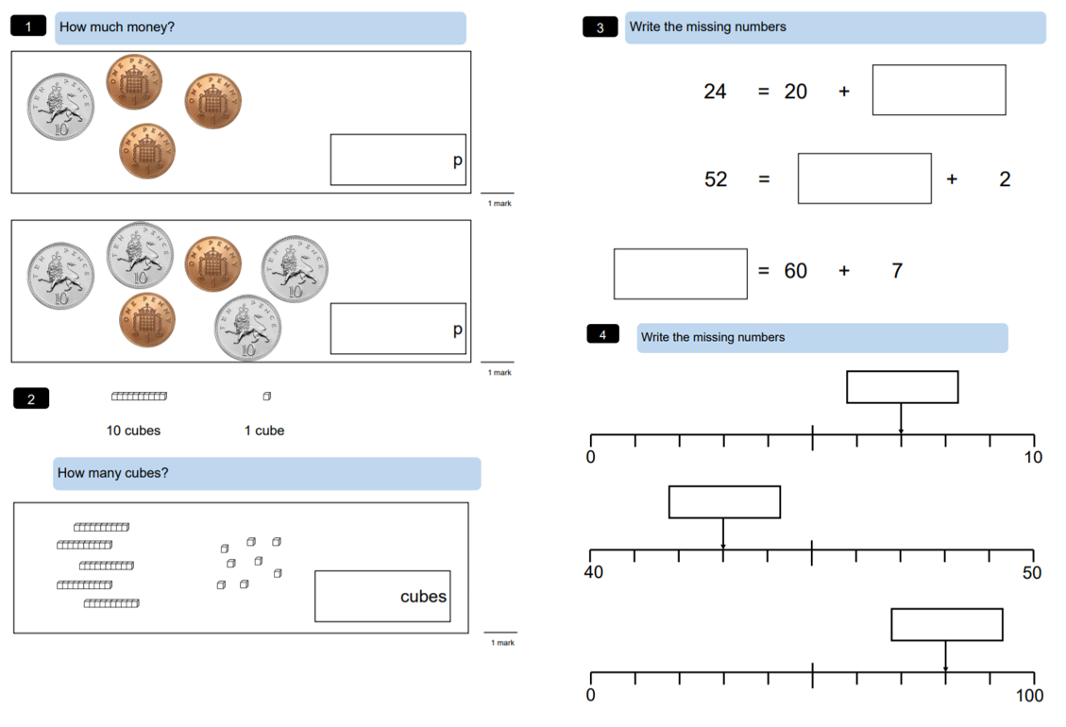

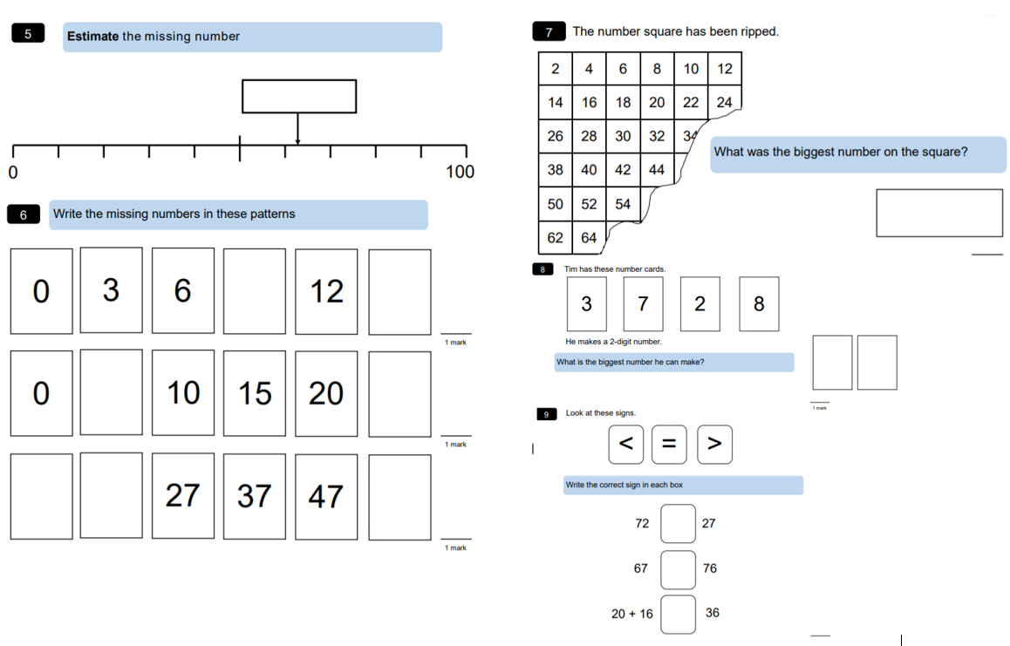
THEMATIC Tuesday 18th – Who was Julius Caesar?
Scan the QR code which will take you to a video on the Oak Nation Academy. As you watch the video, answer these questions – remember that you can pause and rewind at any point to help you answer these questions!

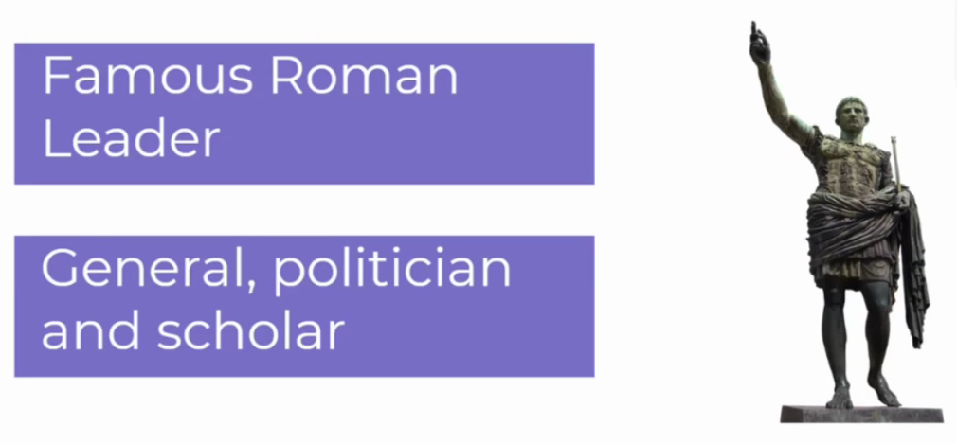
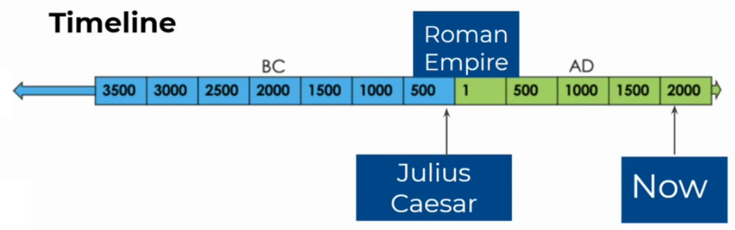
Key Vocabulary:
WORD | DEFINITION
Conquer | To take over somewhere by force
Legions | An army in ancient Rome that was made up of soldiers on foot and on horseback.
Dictator | A ruler / leader who has total power over somewhere
Gaul | An area in Europe during the Roman period

Task 1 – Who was Julius Ceasar?
For each sentence, write down the missing words that complete each one. Remember, rewind the video if you need to refresh yourselves.
generals politician grow

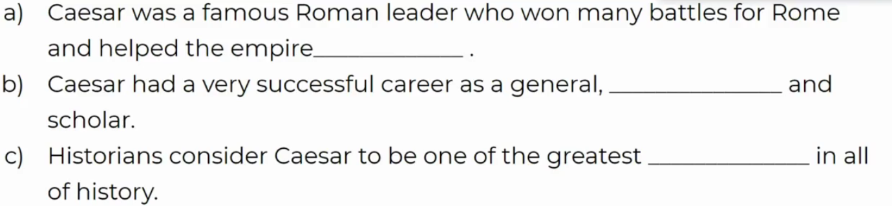
Task 2 –Caesar’s conquering of Gaul?
Which of these sentences are true or false? Remember, rewind the video if you need to refresh yourselves.
 | TRUE | FALSE
Caesar was a commander of the Roman navy during the Gallic Wars.
Caesar’s only aim in the Gallic wars was to expand Rome?
The conquest of Rome expanded the empire to the North Sea.

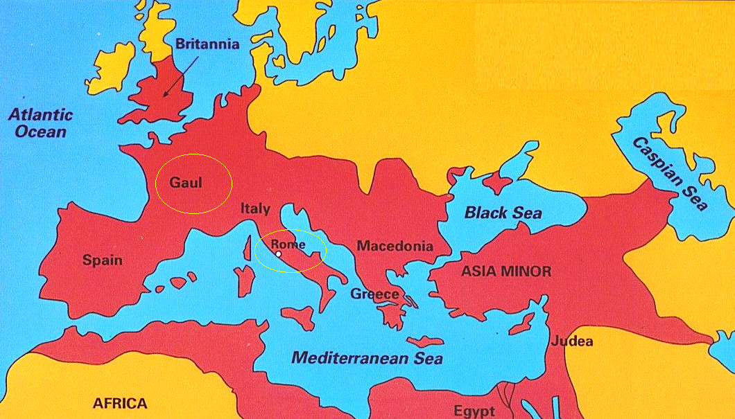

Task 3 –How did Caesar become a dictator?

Answer the following questions, using the sentence stems to help you:

- Why was Caesar worried about returning to Rome?

Caesar was worried about returning to Rome because__________________________

______________________________________________________________________

- What happened at the end of the civil war?
At the end of the civil war, Caesar _____________ his enemies and became _______

______________________________________________________________________

READING Wednesday 19th January 2022 – ‘The Hare and the Tortoise’
Activity 2 – Reading
Read the second section of ‘The tortoise and the Hare’ below:
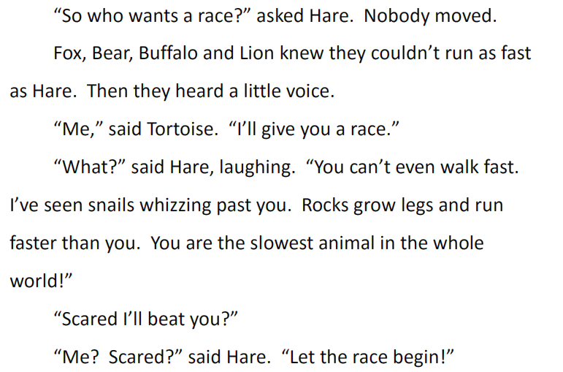
Activity 2 – Questions:
- Which of these animals was NOT in the crowd? Tick the correct answer:

- Which animals says that it will race Hare?
________________________________________________

- Hare laughs at tortoise and says he can’t even walk fast. Draw lines to match what Hare says about snails and rocks.

- The Hare says ‘Rocks grow legs and run faster than you’. What does he mean by this? Use ‘because’ to explain your answer.

WRITING Wednesday 19th January 2022 – Apostrophes for contractions
What are contractions?
Scan the QR code or follow the link to find out more about apostrophes for contractions from the BBC Bitesize website. https://www.bbc.co.uk/bitesize/topics/zvwwxnb/articles/zcyv4qt

You can use apostrophes to show that you have omitted (left out) some letters when you are joining words together.
For example, you can join the words ‘you’ and ‘are’ together.

- You + are = you're.

The apostrophe takes the place of the removed letters. In this example, the letter a.
Sometimes, however, you need to rearrange the letters a bit when you contract the words. For example:
- will + not = won't.
Using contractions like these makes your writing easier to read and more informal.

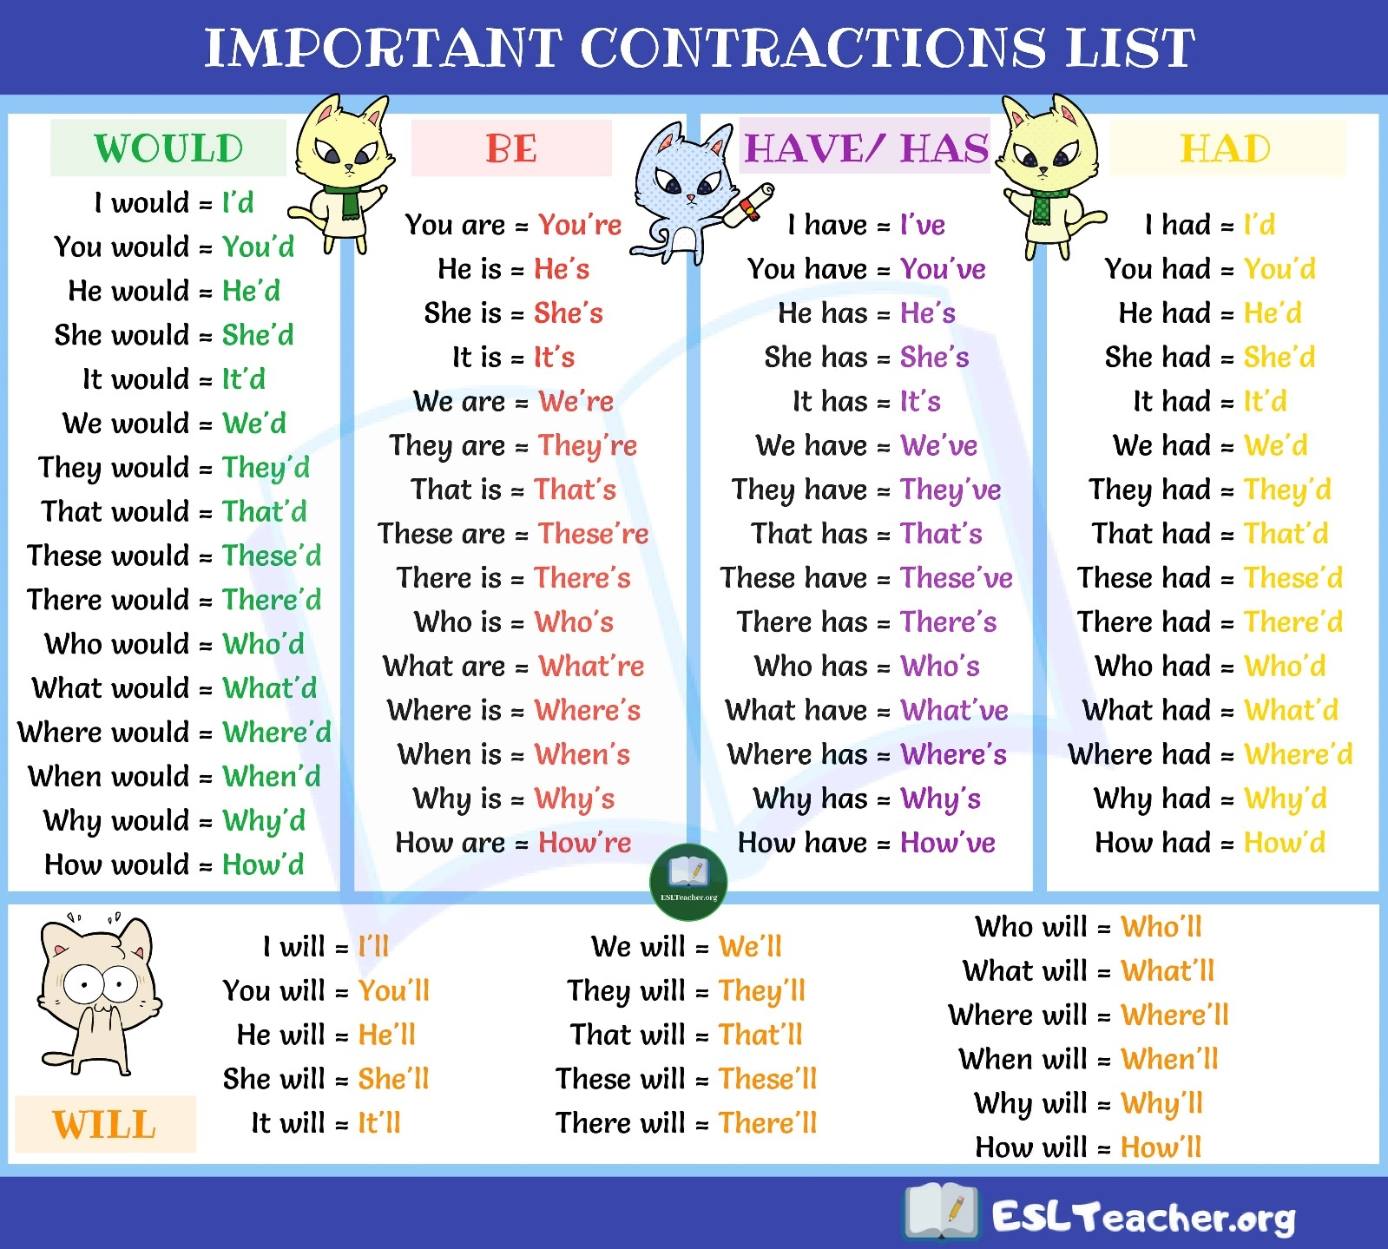
TASK 1: Re-Writing in the contracted form
For each sentence, write the two words in the sentence that can be contracted and the contraction below. The first one has been done for you:
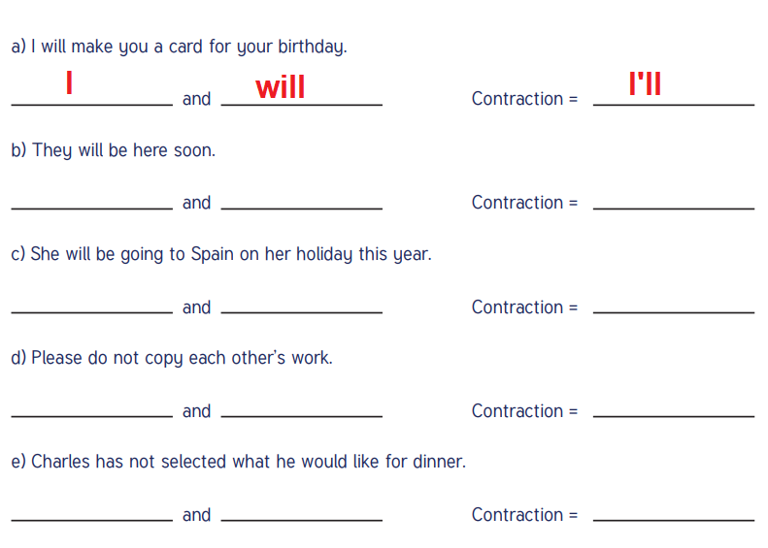

TASK 2: Changing and adding the contracted form

Change the words in brackets into the correct contracted form. Remember to punctuate with apostrophes and capital letters at the start of sentences.

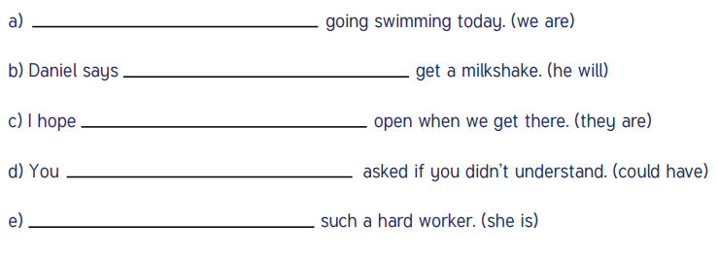
Take a photograph of your sentences using apostrophes for contractions and upload them onto Dojo so that we can share these with the class.

MATHS – Wednesday 19th January 2022 – Addition and Subtraction
STARTER:
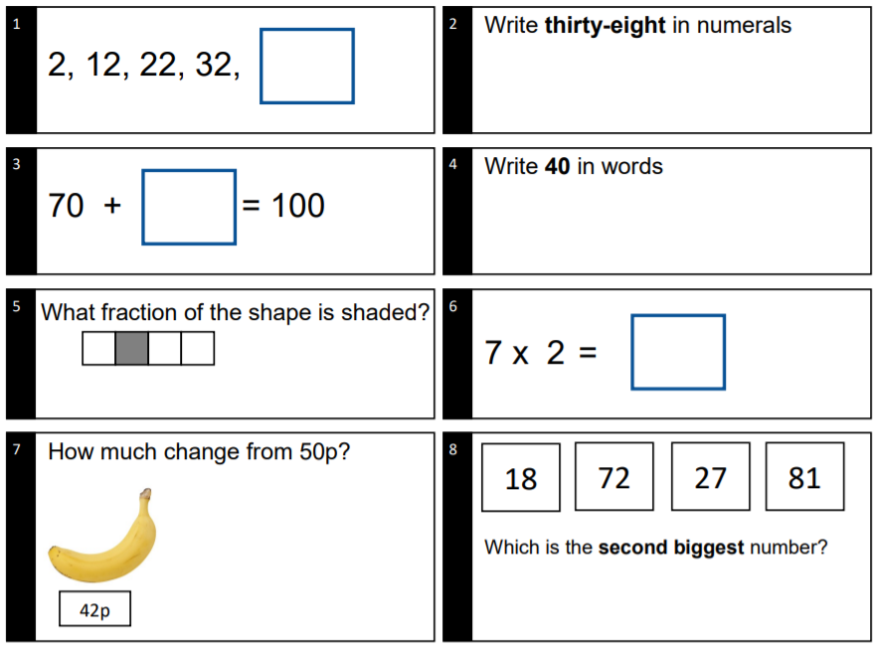

MAIN ACTIVITY:
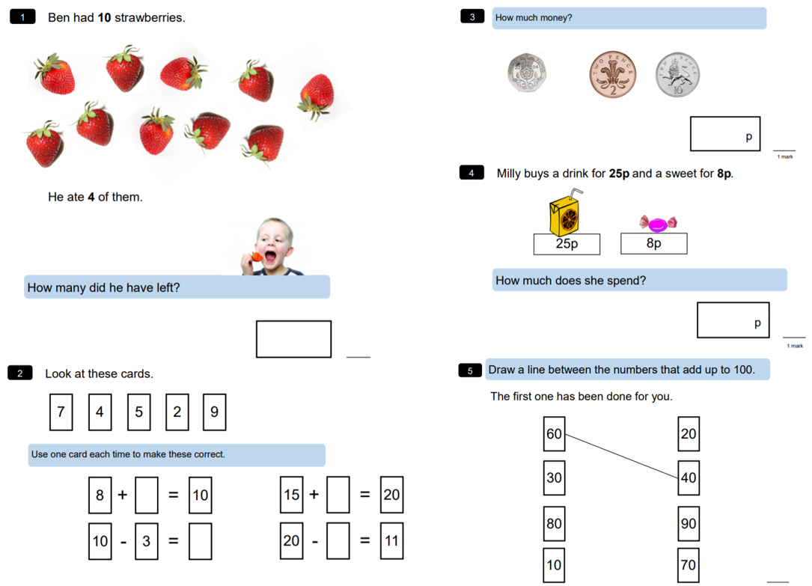

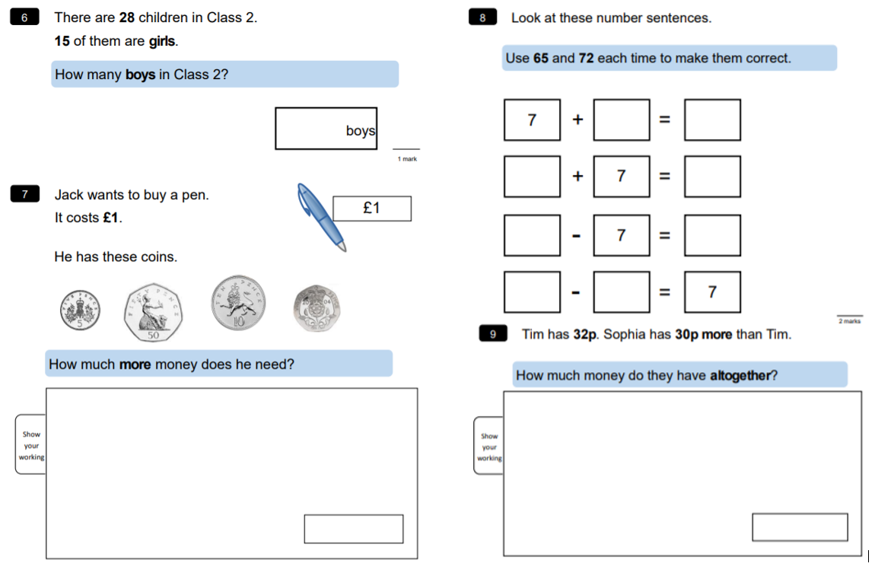
COMPUTING Wednesday 19th January 2022 – Code Breakers

In this activity, you will become code breakers by solving a series of codes related to the first verse of a poem by Roald Dahl.

Learning Skills:
Logical Reasoning – Logical reasoning helps us explain why something happens. Logic is used throughout the activity as you use your existing knowledge of spelling rules and rhyme from the information you are given (the letters) to work out the code.

Decomposition – Decomposition is the process of breaking down a task into smaller, more-manageable parts. It has many advantages. It helps us manage large projects and makes the process of solving a complex problem less daunting and much easier to take on.

Perseverance – Persevering is being determined, resilient, tenacious – never giving up. Persevering is an important skill throughout this activity as you need to keep going despite the fact that you may find some of the codes tricky.

A | B | C | D | E | F | G | H | I | J | K | L | M
1 | 2 | 3 | 4 | 5 | 6 | 7 | 8 | 9 | 10 | 11 | 12 | 13
N | O | P | Q | R | S | T | U | V | W | X | Y | Z
14 | 15 | 16 | 17 | 18 | 19 | 20 | 21 | 22 | 23 | 24 | 25 | 26

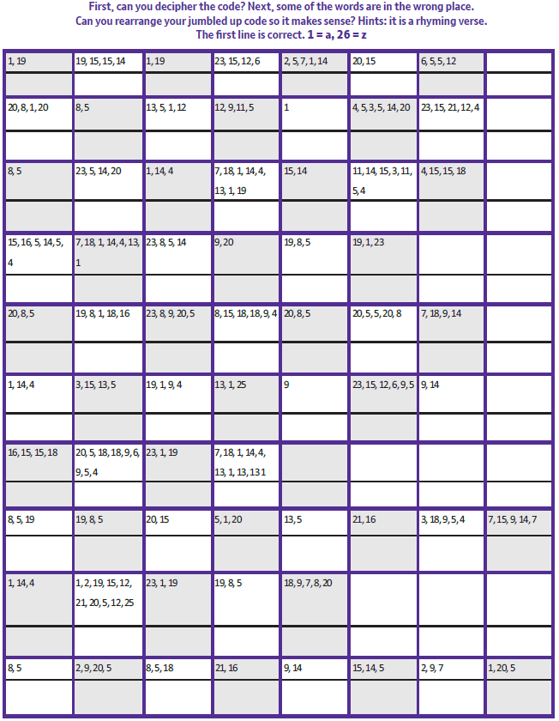

READING Thursday 20th January 2022 – ‘The Hare and the Tortoise’
Activity 1 – Reading
Read the third section of ‘The tortoise and the Hare’ below:
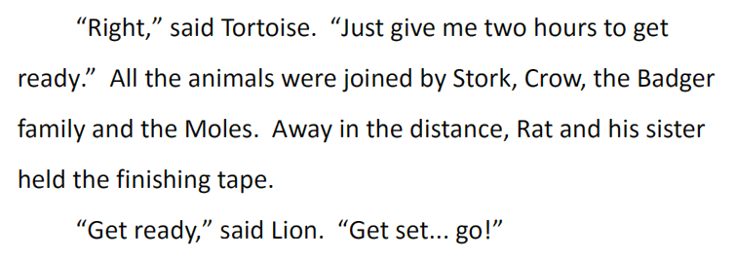
Activity 2 – Questions:

- How long does it take Tortoise to get ready?
____________________________________

- Why might this annoy Hare?
______________________________________________________________________________________________________________________________________________________
- Stork, Crow and Badger family come to watch. What other animals join them?

___________________________________________________________________________
- Who is holding the finishing tape? Tick one.
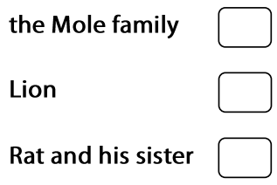

- Who tells Hare and Tortoise to start and how do you know? Use evidence from the text to support your answer.
______________________________________________________________________________________________________________________________________________________

WRITING Thursday 20th January 2022 – Punctuating using Capital letters

Thinking Time:
We use capital letters at the start of sentences, but when else do we use them?

When do we use capital letters?

1) Starting Sentences
- Capital letters are always used to start sentences.
- He loves to eat cake!

2) Proper Nouns
- Proper nouns are naming words for individual people, places, days of the week and months of the year.
- Proper nouns all need capital letters.
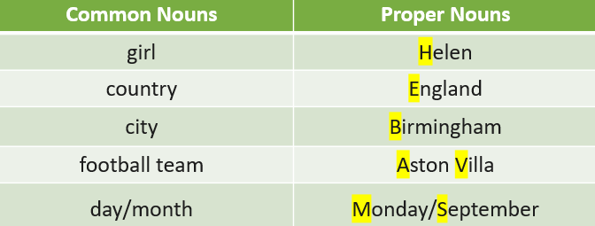

3) The Personal Pronoun ‘I’
- When we are writing about ourselves we use the personal pronoun ‘I’
- I can tell the time.

TASK 1: Adding capital letters
Add capital letters in the right places in these sentences. Remember, the beginnings of sentences, proper nouns and ‘I’ need capital letters!

- it is always snowing in iceland.
- i like going to london.
- mariam and sophia went to the shops in sheffield.
- when i was a baby i didn’t have any teeth.
- my brother zach and i watch football every saturday night.
TASK 2: Rewriting sentences

Read these sentences and correct the capital letters and full stops by writing the sentences underneath.

- i went to the beach and had an ice-cream with sam

________________________________________________________________________

- my mum was very proud of me on friday

________________________________________________________________________

- there were lots of children at the swimming pool on sunday

________________________________________________________________________

- i need to wash my shirt because it is dirty

________________________________________________________________________

- i went to birmingham on a school trip last wednesday

________________________________________________________________________

- chris and sarah said i couldn’t play with them

________________________________________________________________________

Take a photograph of your sentences using accurate capital letters and full stops and upload them onto Dojo so that we can share these with the class.

MATHS – Thursday 20th January 2022 – Addition and Subtraction
STARTER:
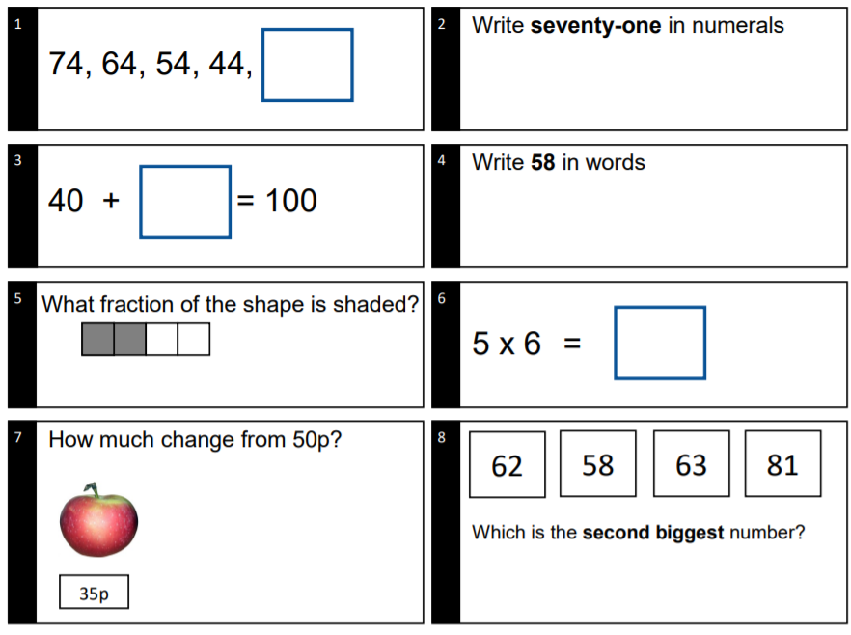

MAIN ACTIVITY:
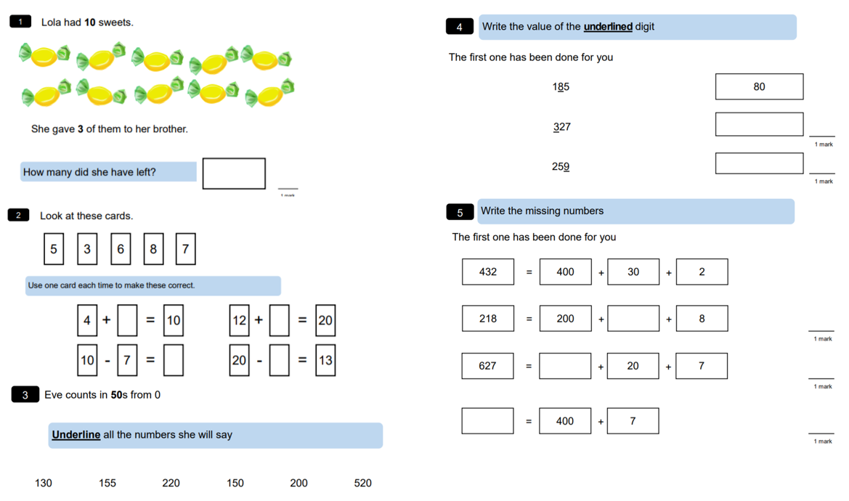

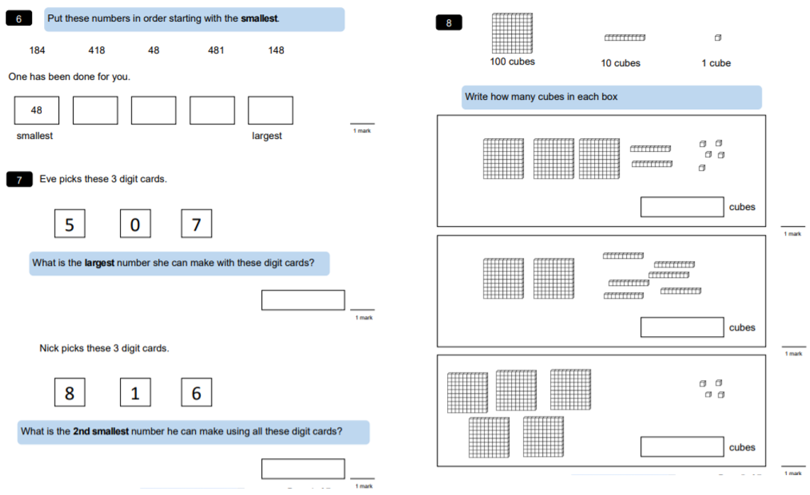
SCIENCE Tuesday 26th January 2021 – How do we classify the diet of animals?
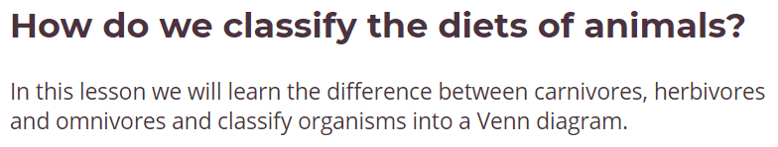

Watch the video by following the link or scanning the QR code.
https://classroom.thenational.academy/lessons/how-do-we-classify-the-diets-of-animals-6rup2c

Suffix ‘-vore’ means to EAT!

TASK 1 – Introductory Quiz:
Follow the link to the quiz which will help you to check any previous learning on this topic and recap anything that you may have forgotten.

TASK 2:
- Name 3 examples of organisms that are herbivores:

- Why do some herbivores have a special digestive system?
______________________________________________________________________

- Why are carnivores sometimes called meat-eaters?
______________________________________________________________________

TASK 3:
Tick which animals in the table are carnivores, herbivores or omnivores.
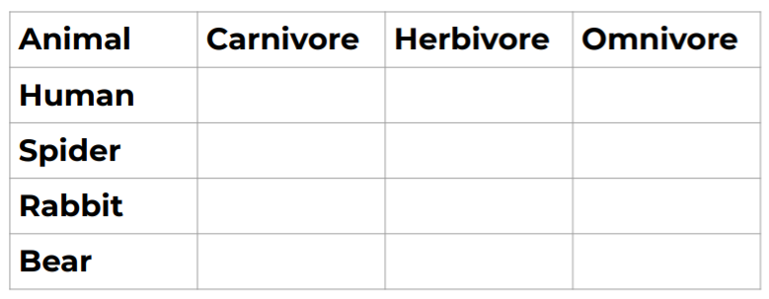

TASK 4:
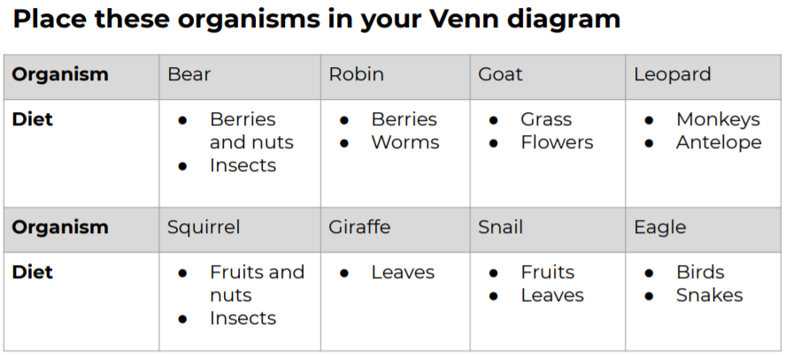

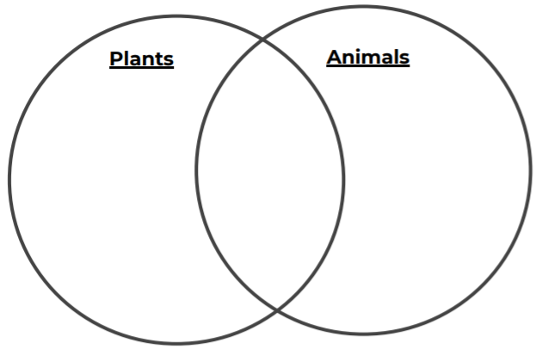
READING Friday 21st January – ‘The Hare and the Tortoise’
Activity 1 – Reading
Read the fourth section of ‘The tortoise and the Hare’ below:
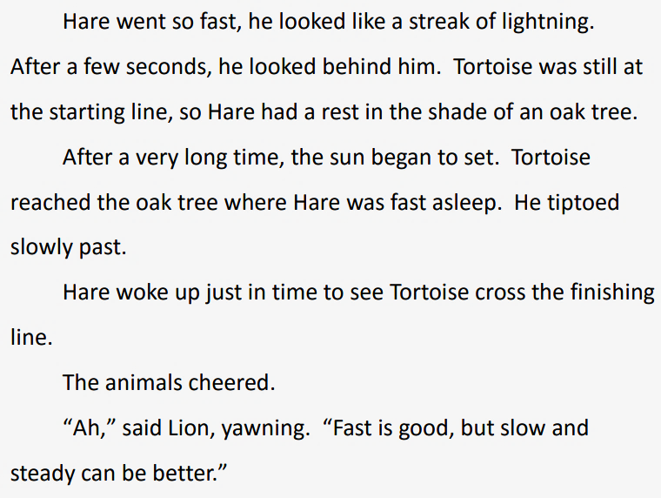
Activity 2 – Questions:

- Hare ’looked like a streak of lightening’. What does this tell you about how he is moving?
______________________________________________________________________________________________________________________________________________________
- Where does Hare stop and have a rest?
_______________________________________

- In what way did tortoise get past Hare while he was having a rest?
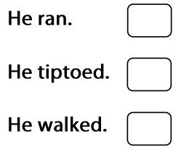
- The animals were happy that tortoise won. How do you know?
_______________________________________

- Write down the phrase that shows you the lion was tired at the end of the race.
_______________________________________
WRITING Friday 21st January 2022 – Commas in a list

RECAP: What is a comma?
,

It is a type of punctuation mark that tells us to take a short pause when we are reading.
The pause is not as long as with a full stop.

A comma can be used to change the meaning of a sentence or to separate items in a list.
Today we will look at how commas are used to separate items in a list.

Scan the QR code or follow the link to learn more about using commas in a list. https://www.bbc.co.uk/bitesize/topics/z8x6cj6/articles/zxvcrdm

Look at this sentence:

- The fruit bowl has oranges and bananas and pears and kiwis and apples in it.

We have used ‘and’ too much here. We can replace the first 3 ‘ands’ with commas.

- The fruit bowl has oranges and bananas and pears and kiwis and apples in it.

- The fruit bowl has oranges, bananas, pears, kiwis and apples in it.

RULE:

A comma is put between each item in the list, but the last two items always have ‘and’ between them and no comma.

Examples:

- The cockerel’s feathers were brown, green, orange and blue.
- The road was busy, noisy and full of activity.
- I need to go to the supermarket to buy eggs, milk, bread, sugar and orange juice.

TASK 1:
Put commas in the correct places in these list sentences. The first one has been done for you.
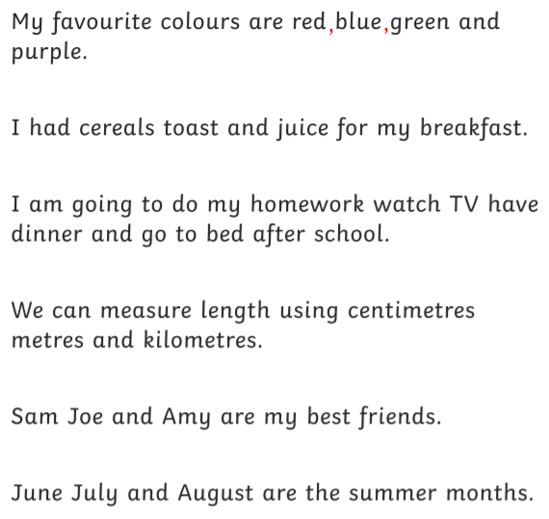
TASK 2:
Rewrite these sentences, putting commas in the correct places in these list sentences.
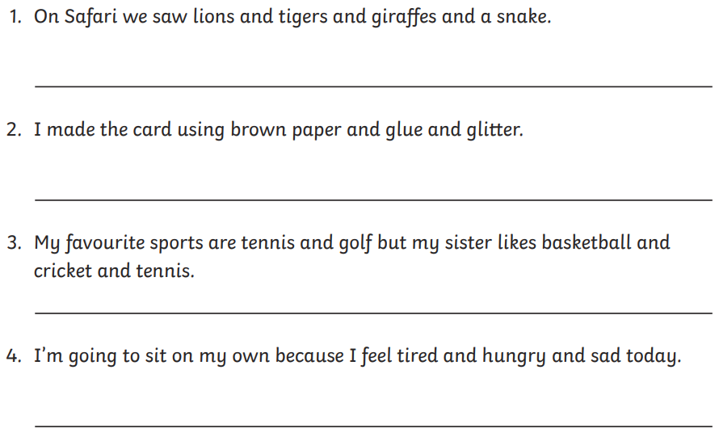

Take a photograph of your sentences using commas in a list and upload them onto Dojo so that we can share these with the class.
MATHS –Friday 21st January 2022 - Multiplication and Division

STARTER:
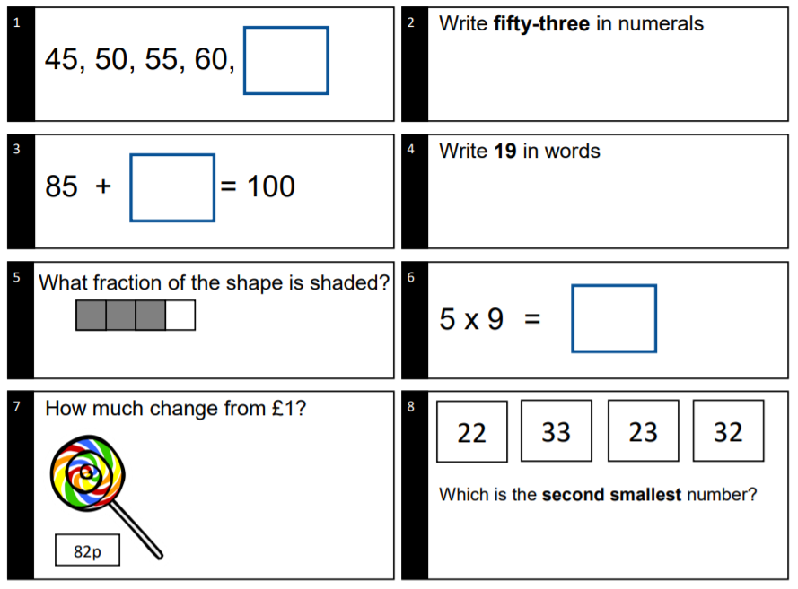

MAIN ACTIVITY:
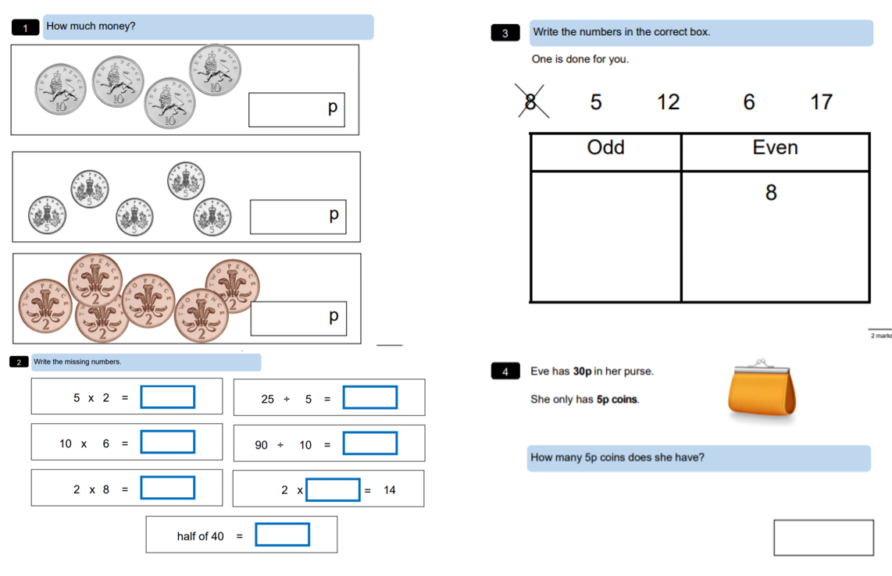
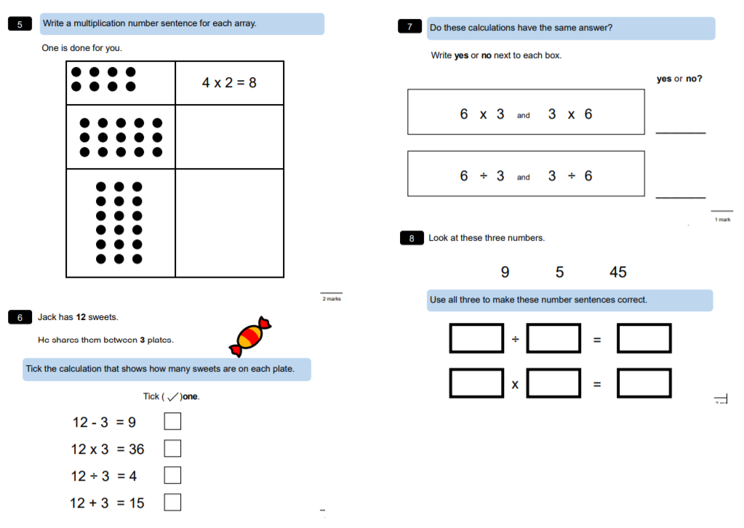

ART /DT Friday 21st January 2022 – Origami Artwork Boats
ORIGAMI
Origami is the art of paper folding, which is often associated with Japanese culture.
Today you will be creating an origami boat and you will need:
- A piece of A4 card / paper
- Patience!
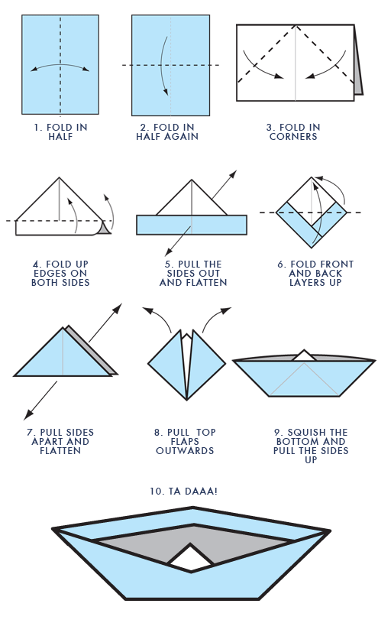
Video Tutorial:
Follow the video tutorial below also to help you and pause throughout:

Share your origami boats with us on class dojo and test them out to see if they float!

Extension:
By following different tutorials, can you create anything else using the art of origami?

PE – Friday 21st January 2022 - Catch and Clap
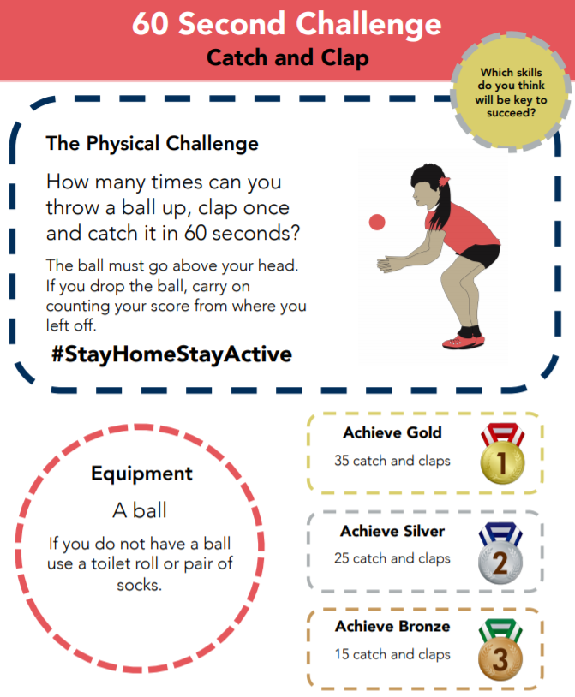

TOP TIP: You can use a pair of socks if you cannot find a ball!
Share some pictures and videos of you completing the challenge and share these with us in ClassDojo and we will see if we have an overall winner for the class!

