Year 4 Pack 1

Wednesday 18th January – Friday 21st January 2022

READING Tuesday 17th January 2022 – ‘Mr. Gum’ by Andy Stanton
Session 1 – Blurb:
The piece of writing we will be focusing on for our reading this week is from a book called ‘You’re a Bad Ma, Mr Gum’ by Andy Stanton

Activity 1:
Read the blurb carefully to get an idea of what the story may be about, then answer the questions below.

- What does the writer mean when he describes Mr Gum as a ‘complete horror’?

________________________________________________________________________________________________________________________________________________________________

- Name 3 other characters that are discussed in the book:

________________________________________________________________________________________________________________________________________________________________________________________________________________________________________________

- Based on this short piece of information in the blurb, make a prediction on what you think may happen in this book between the characters.

________________________________________________________________________________________________________________________________________________________________________________________________________________________________________________

WRITING Tuesday 18th January 2022 – Inverted commas in direct speech
Based on your writing over the last half term, we will be looking at a range of areas in our punctuation and grammar that will improve our writing and build your independence in creating exciting sentences this week and over the next half term. Today we will be looking at inverted commas.

What are inverted commas?
Scan the QR code or follow the link to find out more about inverted commas from the Oak National Academy.
https://classroom.thenational.academy/lessons/to-practise-speech-with-punctuation-68rp8e?step=1&activity=video

When you are writing, inverted commas (also called speech marks) go before and after any words that a character or person says.

For example: "I'm hungry," complained Goldilocks.

‘I’m hungry’ are the words that Goldilocks says out loud (also called direct speech), so the inverted commas go at the start and end of those words, with either a comma, exclamation mark or question mark before the second inverted comma. (, ! ?)

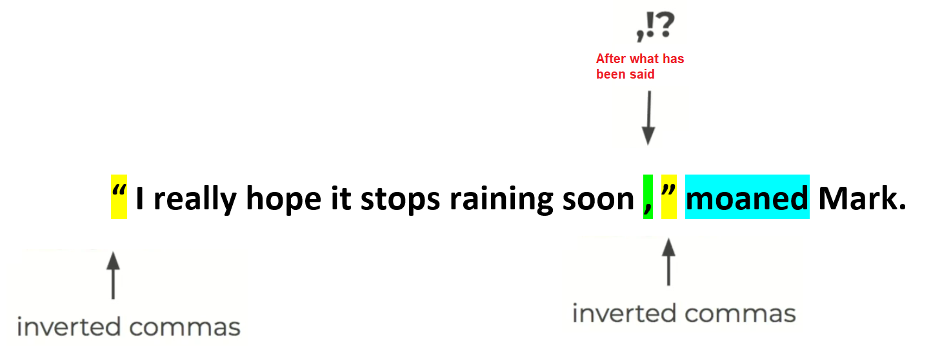
TASK 1 – Synonyms for said:
We use inverted commas for when people are speaking, but it can be very boring when we keep using the word ‘said’. How many different synonyms (words that mean the same or are similar) can you come up with? Two examples have been done for you:
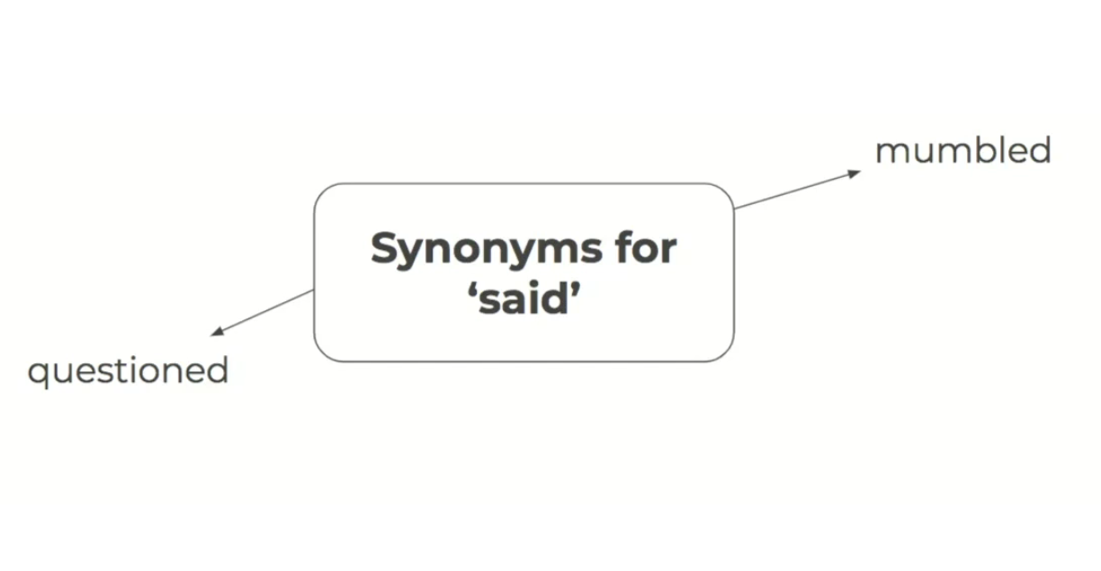
TASK 2 – Adding inverted commas
Below are some sentences with the inverted commas missing. For each sentence, underline the section that is being spoken and include the inverted commas into the correct place. The first two have been done for you.

- “ What’s for dinner dad? ” Jacinda asked.
- The witch looked at her sisters and asked, “ When will we three meet again? ”
- The mouse looked at the fox and whispered, Please don’t eat me.
- I’m stuck! Shouted Sam as he held up his hands.
- We won! We won! Screamed the boys as the final whistle blew.
- John, can you hold this? asked the sweet old lady.
- Be careful in the snow, it is really slippy out there, said her father.
- The policeman asked, Can I see your licence please?
- The teacher stood up and replied, Make sure you have checked your answers children.
TASK 3 – Inserting missing punctuation:
Mr Jenkins and Miss Schweizer have forgotten to include inverted commas and full stops in their writing below. Read the section carefully and add the inverted commas and full stops into the correct places.

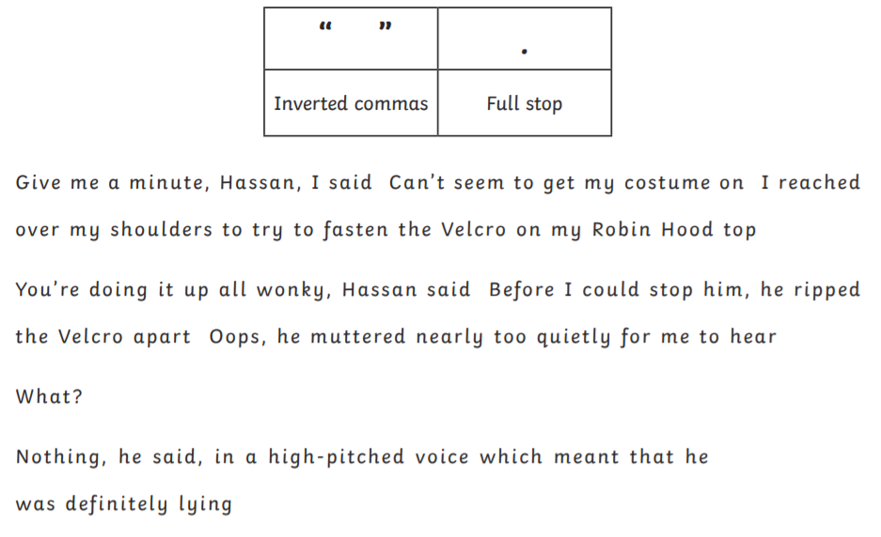

EXTENSION:
Now you have practiced adding inverted commas into sentences, have a go at creating your own sentences using inverted commas for direct speech. Remember to punctuate them correctly!

Take a photograph of your sentences using inverted commas for speech and upload them onto Dojo so that we can share these with the class.
MATHS – Tuesday 18th January 2022 – Number and Place Value
STARTER:
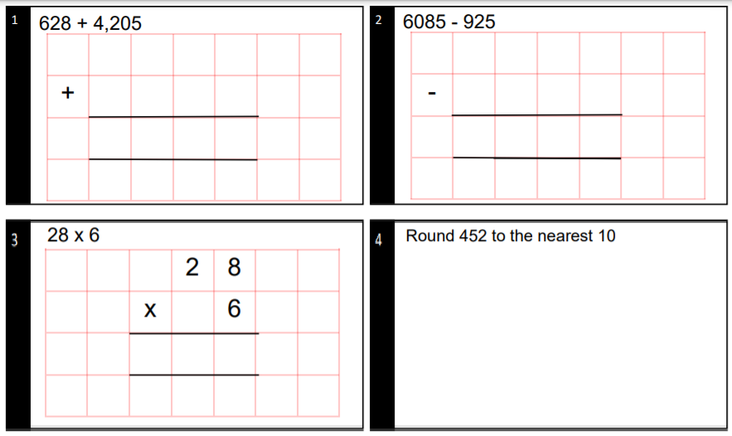

MAIN ACTIVITY:
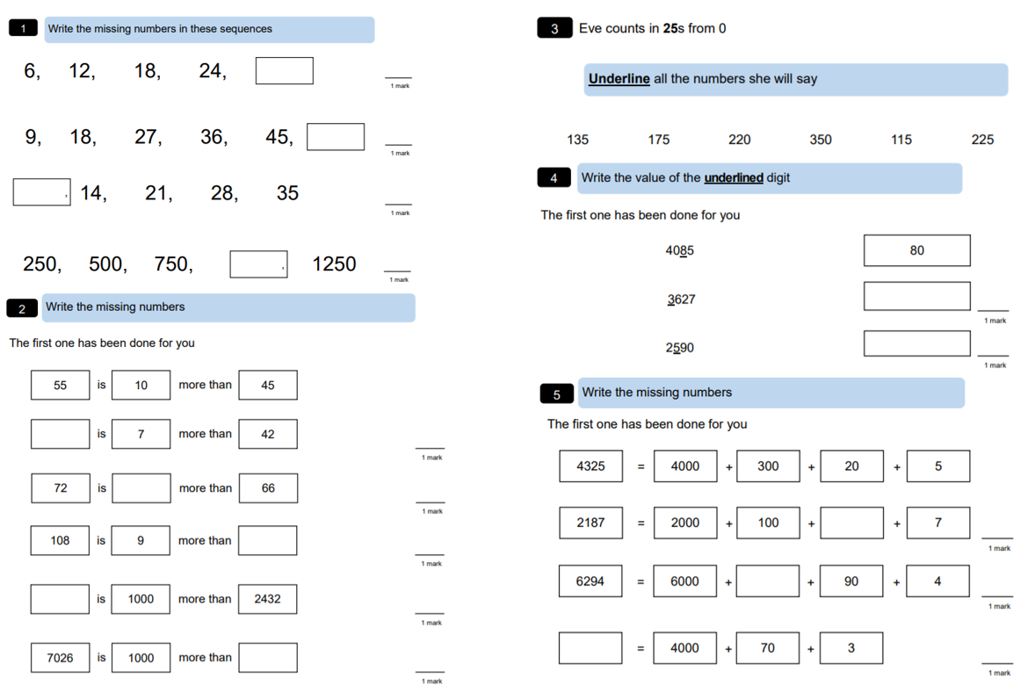
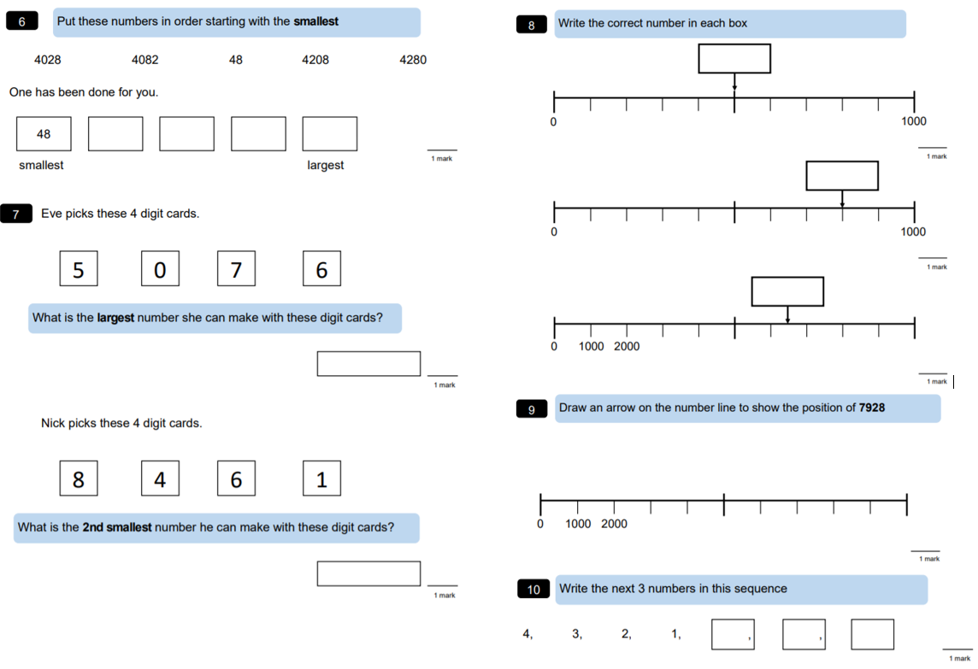

EXTENSION:
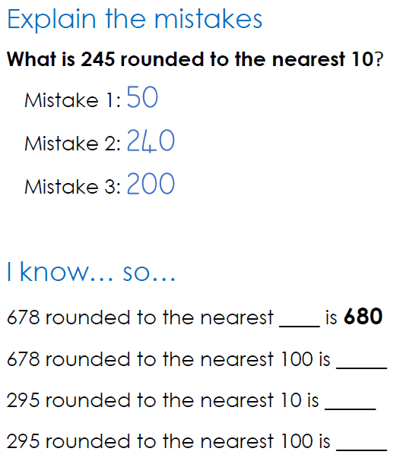

THEMATIC Tuesday 18th – Who was Julius Caesar?
Scan the QR code which will take you to a video on the Oak Nation Academy. As you watch the video, answer these questions – remember that you can pause and rewind at any point to help you answer these questions!

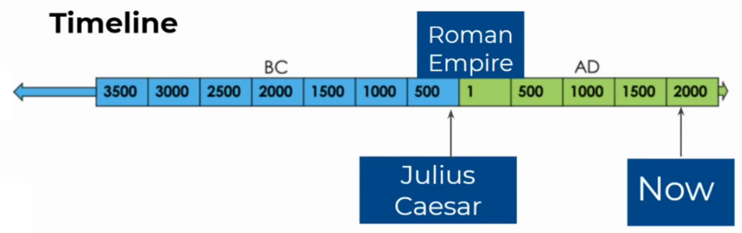
Key Vocabulary:
WORD | DEFINITION
Conquer | To take over somewhere by force
Legions | An army in ancient Rome that was made up of soldiers on foot and on horseback.
Dictator | A ruler / leader who has total power over somewhere
Gaul | An area in Europe during the Roman period

Task 1 – Who was Julius Ceasar?
For each sentence, write down the missing words that complete each one. Remember, rewind the video if you need to refresh yourselves.
generals politician grow

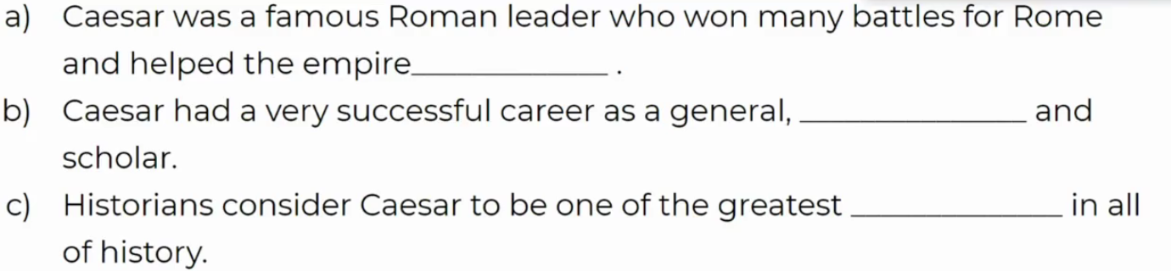
Task 2 –Caesar’s conquering of Gaul?
Which of these sentences are true or false? Remember, rewind the video if you need to refresh yourselves.
 | TRUE | FALSE
Caesar was a commander of the Roman navy during the Gallic Wars.
Caesar’s only aim in the Gallic wars was to expand Rome?
The conquest of Rome expanded the empire to the North Sea.

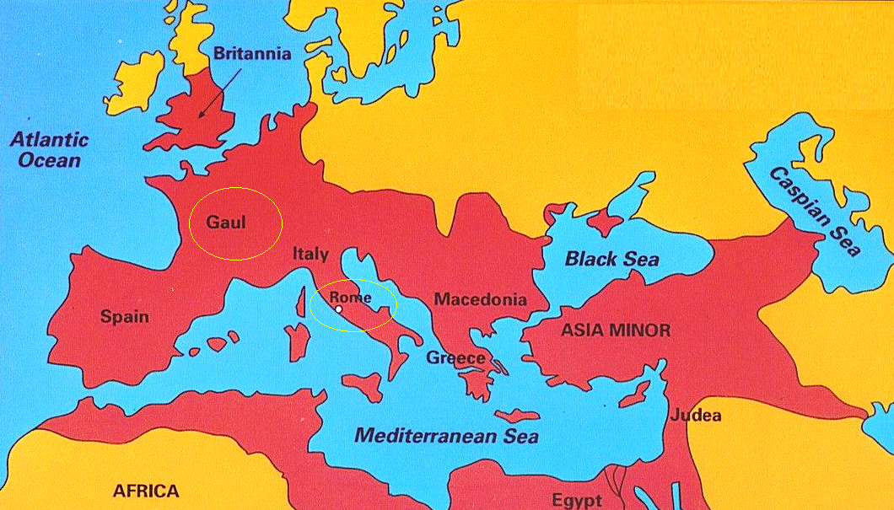

Task 3 –How did Caesar become a dictator?

Answer the following questions, using the sentence stems to help you:

- Why was Caesar worried about returning to Rome?

Caesar was worried about returning to Rome because__________________________

______________________________________________________________________

- What happened at the end of the civil war?
At the end of the civil war, Caesar _____________ his enemies and became _______

______________________________________________________________________

READING Wednesday 19th January 2022 – ‘Mr. Gum’ by Andy Stanton

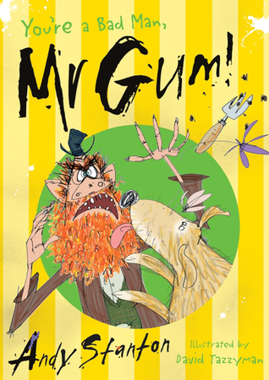
Mr Gum hates children, animals, fun and corn on the cob. This book is about him, an angry fairy, a dog called Jake and a little girl called Polly.

TASK 1 - READING:
Read the extract below which describes where Mr Gum lives:

EXTRACT 1:
Mr Gum’s bedroom was absolutely grimsters. The wardrobe contained so much mould and old cheese that there was hardly any room for his moth-eaten clothes, and the bed was never made. (I don’t mean that the duvet was never put back on the bed, I mean the bed had never even been MADE. Mr Gum hadn’t gone to the bother of assembling it. He had just chucked all the bits of wood on the floor and dumped a mattress on top.) There was broken glass in the windows and the ancient carpet was the colour of unhappiness and smelt like a toilet.

Anyway, I could be here all day going on about Mr Gum’s house but I think you’ve got the idea. Mr Gum was an absolute lazer who couldn’t be bothered with niceness and tidying and brushing his teeth, or anyone else’s teeth for that matter.

BUT (and as you can see, it’s a big but) he was always extremely careful to keep his garden tidy. In fact, Mr Gum kept his garden so tidy that it was the prettiest, greeniest, floweriest, garden in the whole of Lamonic Bibber.

TASK 2 – Reflection Questions:
- What do you learn about Mr Gum’s personality in this opening extract? What evidence is there to support this based on his house?
________________________________________________________________________________________________________________________________________________________________________________________________________________________________________________
- What is surprising about his garden and why?

________________________________________________________________________________________________________________________________________________________________________________________________________________________________________________
Do not forget to share your answers with us on ClassDojo.

WRITING Wednesday 19th January 2022 – Apostrophes for contractions
What are contractions?
Scan the QR code or follow the link to find out more about apostrophes for contractions from the BBC Bitesize website. https://www.bbc.co.uk/bitesize/topics/zvwwxnb/articles/zcyv4qt

You can use apostrophes to show that you have omitted (left out) some letters when you are joining words together.
For example, you can join the words ‘you’ and ‘are’ together.

- You + are = you're.

The apostrophe takes the place of the removed letters. In this example, the letter a.
Sometimes, however, you need to rearrange the letters a bit when you contract the words. For example:
- will + not = won't.
Using contractions like these makes your writing easier to read and more informal.

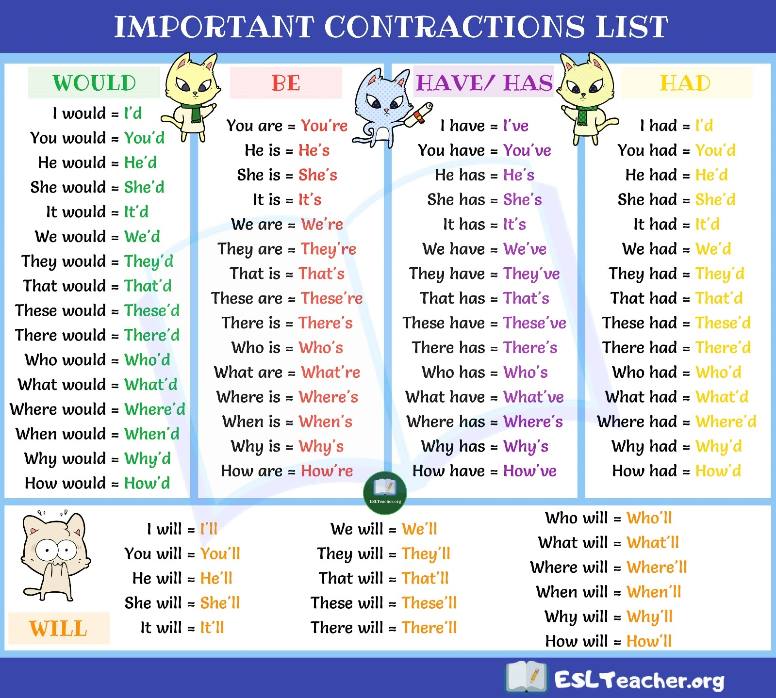

TASK 1: Re-Writing in the contracted form
For each sentence, write the two words in the sentence that can be contracted and the contraction below. The first one has been done for you:
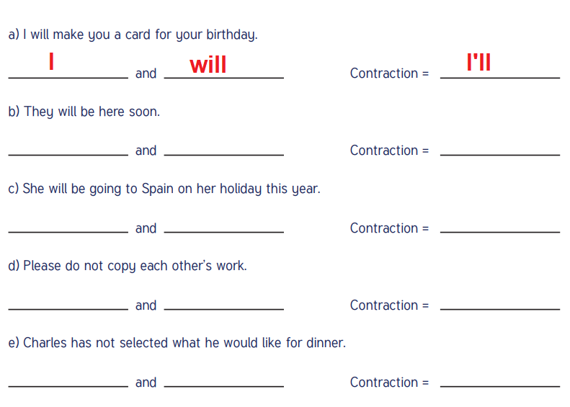

TASK 2: Correct or incorrect use of contractions?
Look at these sentences. Has the apostrophe been used correctly or incorrectly? Use the contraction list above to support you.

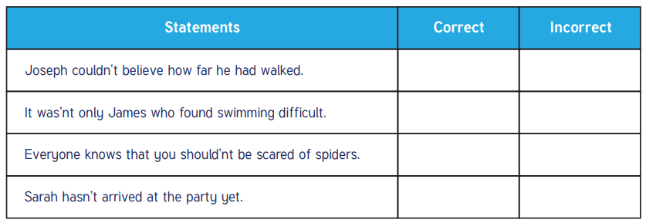

TASK 3: Changing and adding the contracted form

Change the words in brackets into the correct contracted form. Remember to punctuate with apostrophes and capital letters at the start of sentences.

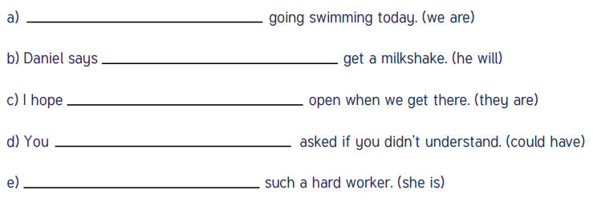

CHALLENGE:
Look at the words in the box. Put the words together to make contractions. Create five sentences which include at least one contraction in each.

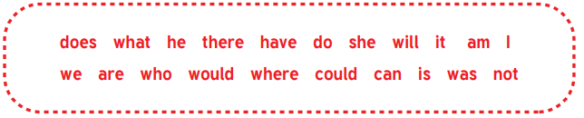
Take a photograph of your sentences using apostrophes for contractions and upload them onto Dojo so that we can share these with the class.
MATHS – Wednesday 19th January 2022 – Addition and Subtraction
STARTER:
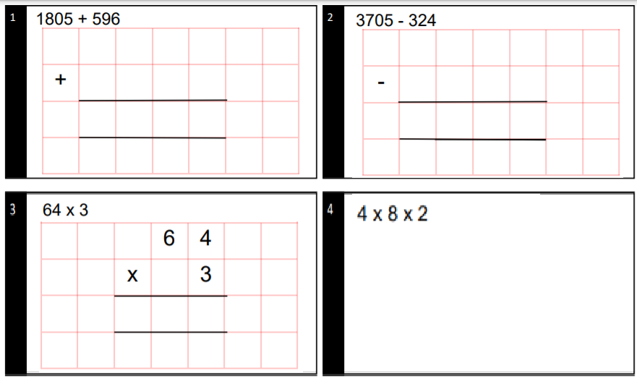

MAIN ACTIVITY:
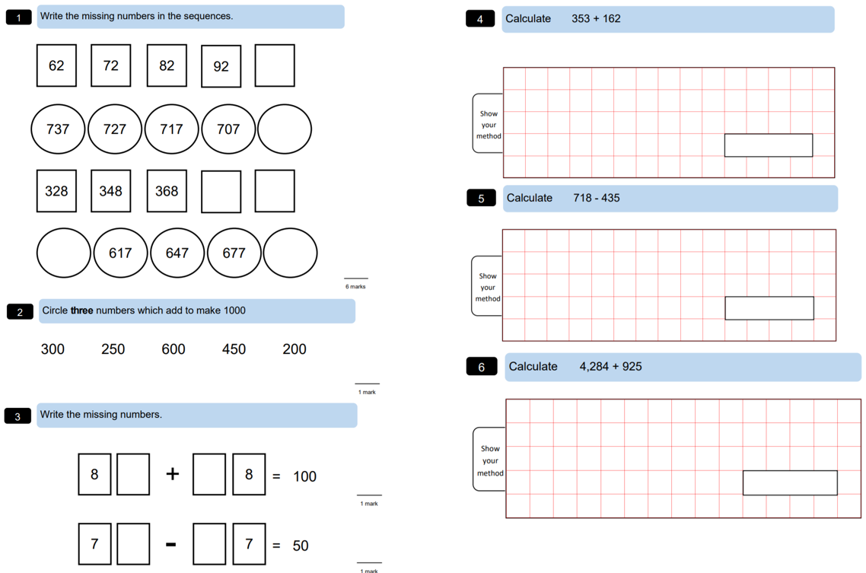

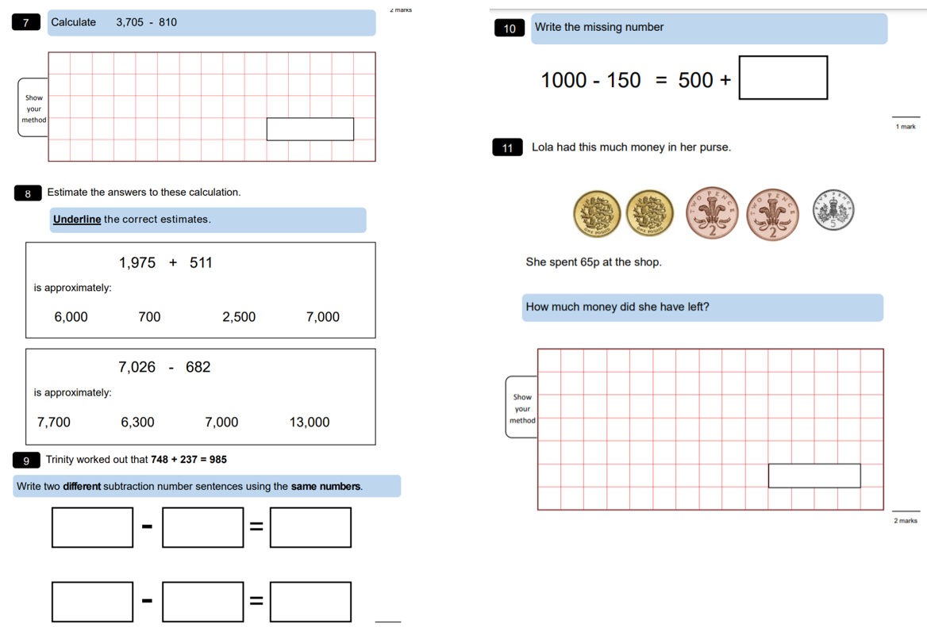
EXTENSION:
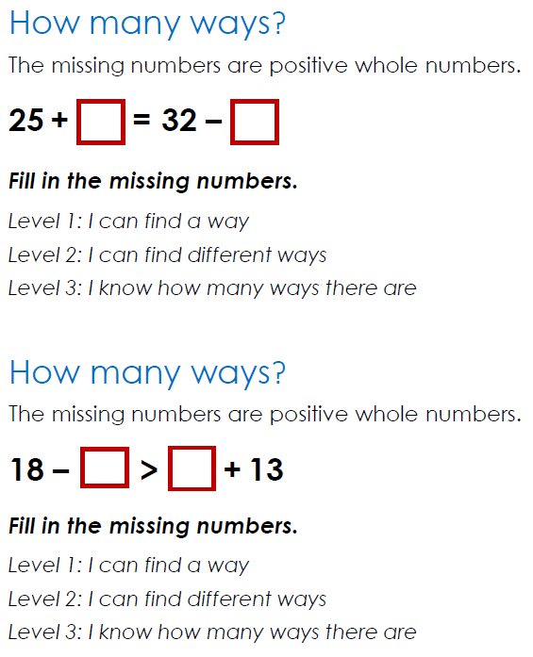

COMPUTING Wednesday 19th January 2022 – Code Breakers

In this activity, you will become code breakers by solving a series of codes related to the first verse of a poem by Roald Dahl.

Learning Skills:
Logical Reasoning – Logical reasoning helps us explain why something happens. Logic is used throughout the activity as you use your existing knowledge of spelling rules and rhyme from the information you are given (the letters) to work out the code.

Decomposition – Decomposition is the process of breaking down a task into smaller, more-manageable parts. It has many advantages. It helps us manage large projects and makes the process of solving a complex problem less daunting and much easier to take on.

Perseverance – Persevering is being determined, resilient, tenacious – never giving up. Persevering is an important skill throughout this activity as you need to keep going despite the fact that you may find some of the codes tricky.

A | B | C | D | E | F | G | H | I | J | K | L | M
1 | 2 | 3 | 4 | 5 | 6 | 7 | 8 | 9 | 10 | 11 | 12 | 13
N | O | P | Q | R | S | T | U | V | W | X | Y | Z
14 | 15 | 16 | 17 | 18 | 19 | 20 | 21 | 22 | 23 | 24 | 25 | 26

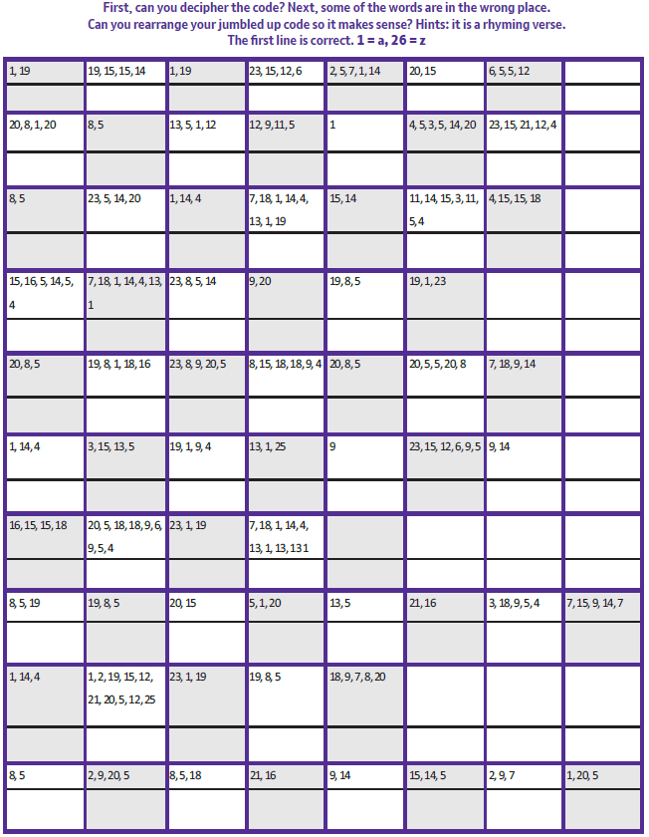

READING Thursday 20th January 2022 – ‘Mr. Gum’ by Andy Stanton
TASK 1 - READING:
Read the extract below again, which describes where Mr Gum lives:

EXTRACT 1:
Mr Gum’s bedroom was absolutely grimsters. The wardrobe contained so much mould and old cheese that there was hardly any room for his moth-eaten clothes, and the bed was never made. (I don’t mean that the duvet was never put back on the bed, I mean the bed had never even been MADE. Mr Gum hadn’t gone to the bother of assembling it. He had just chucked all the bits of wood on the floor and dumped a mattress on top.) There was broken glass in the windows and the ancient carpet was the colour of unhappiness and smelt like a toilet.

Anyway, I could be here all day going on about Mr Gum’s house but I think you’ve got the idea. Mr Gum was an absolute lazer who couldn’t be bothered with niceness and tidying and brushing his teeth, or anyone else’s teeth for that matter.

BUT (and as you can see, it’s a big but) he was always extremely careful to keep his garden tidy. In fact, Mr Gum kept his garden so tidy that it was the prettiest, greeniest, floweriest, garden in the whole of Lamonic Bibber.

TASK 2 – Retrieval Questions:
- According to the text, what could Mr Gum ‘not be bothered…’ with?
________________________________________________________________________________________________________________________________________________________________

- Tick one box in each row to show whether each statement is true or false.
 |  | True | False
There was lots of room in his wardrobe for his clothes
The ancient carpet was a pleasant colour
Mr Gum was very proud of his garden

- Write down three adjectives that are used to describe Mr. Gum’s garden. ___________________________________________________________ ___________________________________________________________
___________________________________________________________
WRITING Thursday 20th January 2022 – Apostrophes for possession

Yesterday you looked at using apostrophes in contractions (omission – missing letters). Think about these questions and share your answers with someone at home:
- What is a contraction?
- What does the apostrophe represent?
- What examples of contractions can you think of?
In today’s lesson, you will be looking at another use of apostrophes – possession.

What are apostrophes of possession?
Scan the QR code or follow the link to find out more about apostrophes for possession from the BBC Bitesize website. https://www.bbc.co.uk/bitesize/topics/zvwwxnb/articles/zx9ydxs

Apostrophes can be used to show that something belongs to someone or something. This is called possession.

Singular plural:
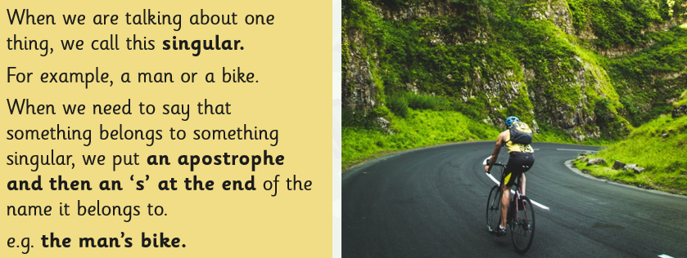

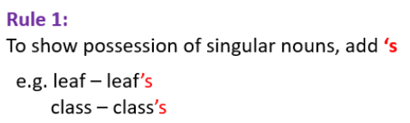

- The forest’s light is always changing.
- Rachel’s favourite sport is running.
- The cat’s eyes are different colours.
- Catherine’s house is old and large.

TASK 1 – Adding apostrophes to singular plurals
Rewrite the sentences with the apostrophe in the correct place for the singular plural.

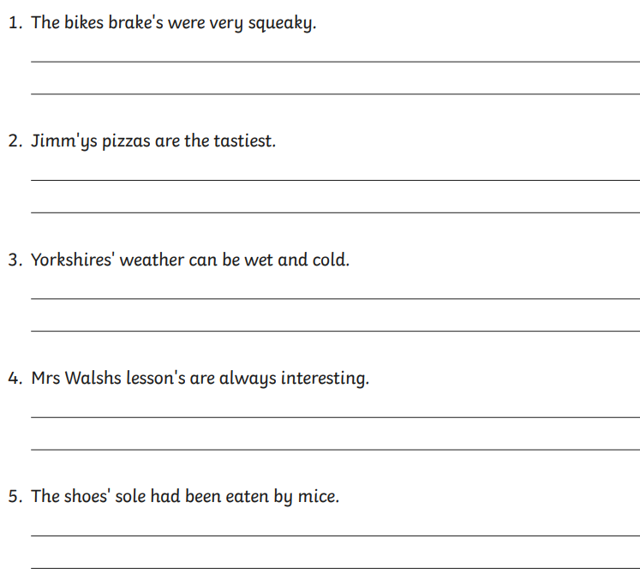

TASK 2: Changing sentences to show possession with an apostrophe

Change the sentences below so that they each contain an apostrophe to show possession by a singular noun.
For example:

- The rays belonging to the sun shone on the ground.
- The sun’s rays shone on the ground.

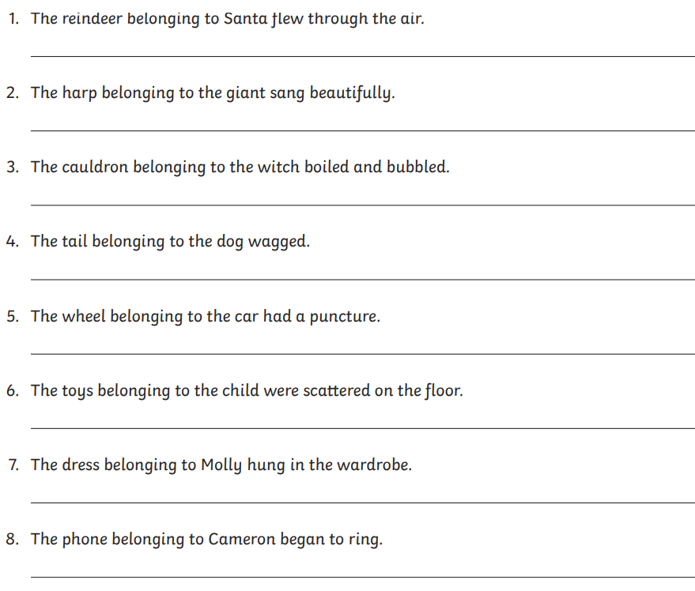

Share your possessive apostrophe sentences with is on ClassDojo and check your work against the answers at the end of the day!

MATHS – Thursday 20th January 2022 – Multiplication and Division
STARTER:
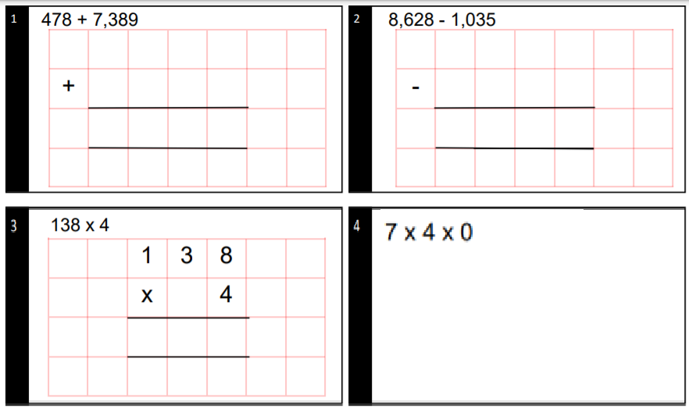

MAIN ACTIVITY:
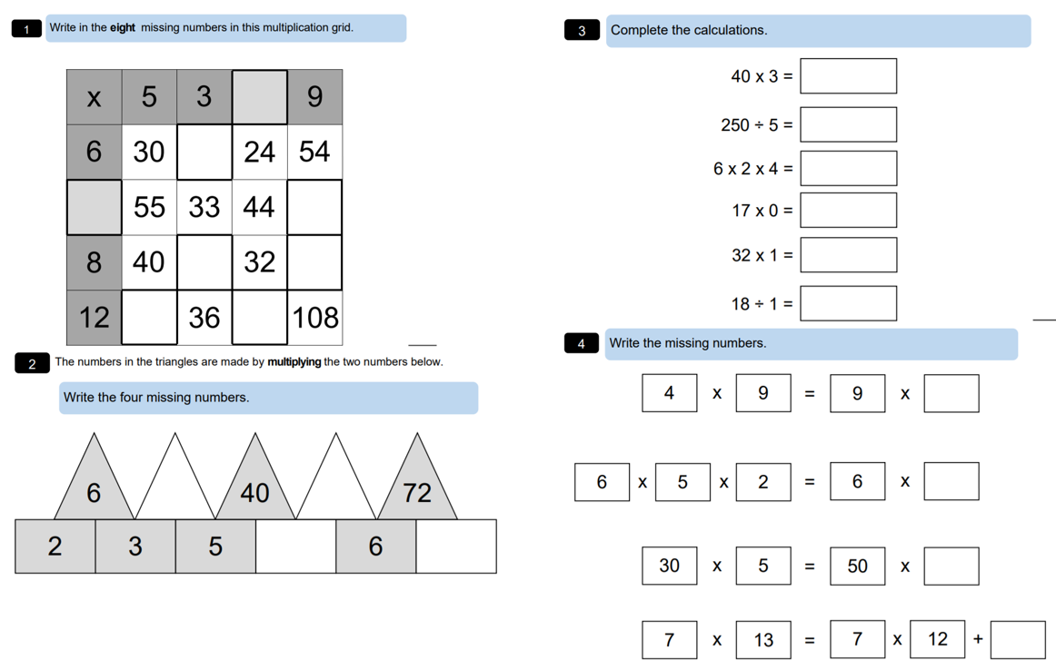
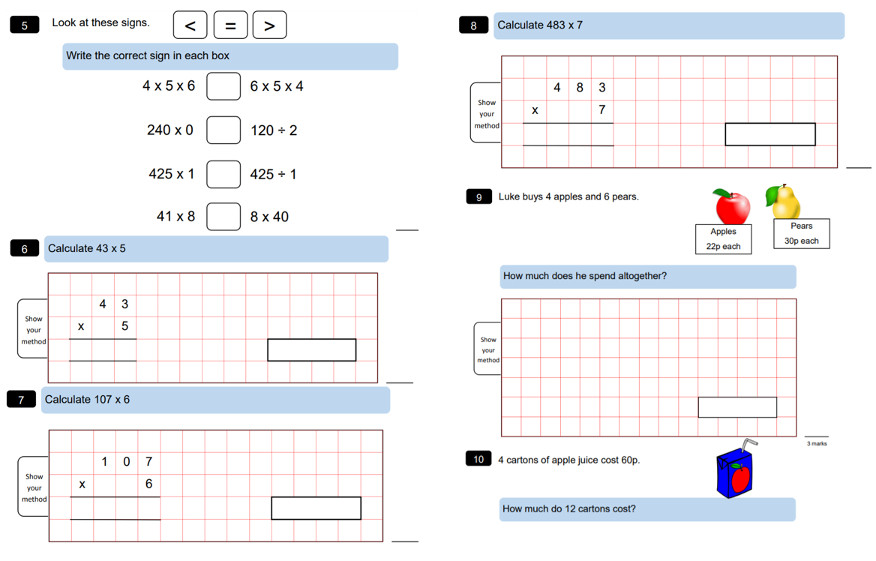
EXTENSION:
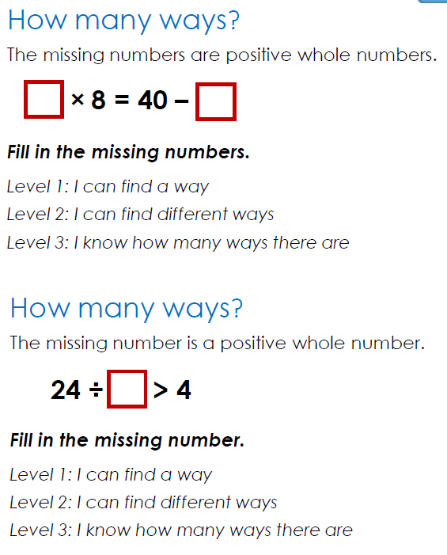

SCIENCE Tuesday 26th January 2021 – How do we classify the diet of animals?
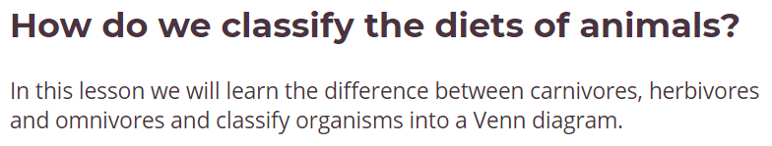

Watch the video by following the link or scanning the QR code.
https://classroom.thenational.academy/lessons/how-do-we-classify-the-diets-of-animals-6rup2c

Suffix ‘-vore’ means to EAT!

TASK 1 – Introductory Quiz:
Follow the link to the quiz which will help you to check any previous learning on this topic and recap anything that you may have forgotten.

TASK 2:
- Name 3 examples of organisms that are herbivores:

- Why do some herbivores have a special digestive system?
______________________________________________________________________

- Why are carnivores sometimes called meat-eaters?
______________________________________________________________________

TASK 3:
Tick which animals in the table are carnivores, herbivores or omnivores.
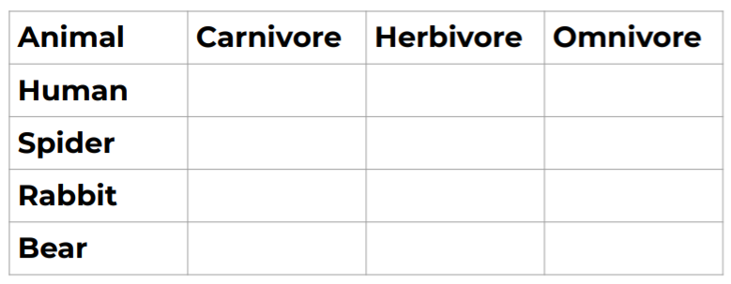

TASK 4:
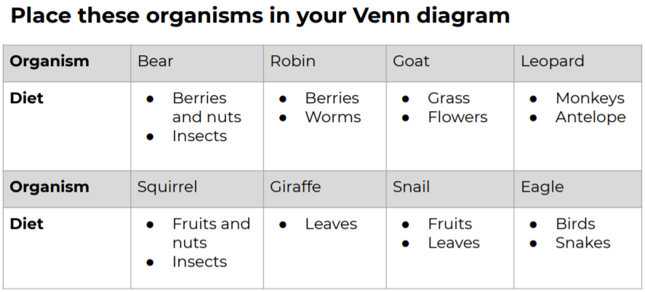

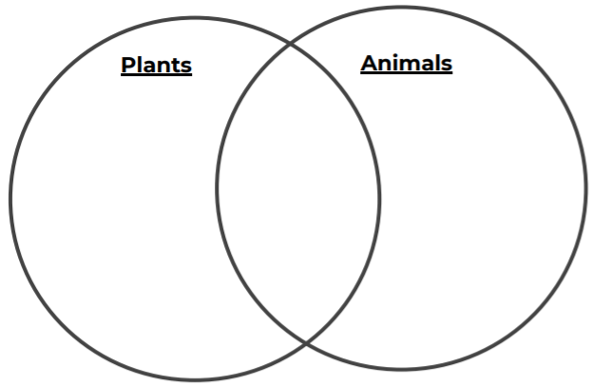
READING Friday 21st January – ‘Mr. Gum’ by Andy Stanton
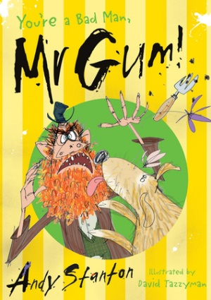
TASK 1 - READING:
Read the extract below, where something happens to Mr Gum’s garden:

EXTRACT 2:
Sort out the garden, you lazy snorer!’ yelled the fairy, and down came the frying pan.
Mr Gum was too fast this time and shot out of bed like a guilty onion. PFFF! went the frying pan as it hit the bedcovers, sending up a little cloud of dust and ants.
Mr Gum legged it out of the bedroom and went hurtling down the stairs. He stepped on an old slice of pizza lying in the hall and half skidded into the kitchen, riding it like a cheese and tomato surfboard. He could hear the fairy right behind him, shrieking with fury.
'I ’aven’t done nothin’ wrong! I kept the flippin’ garden TIDY!’ shouted Mr Gum as he flung open the back door and ran outside. He started to say something else but when he saw the garden the words got stuck in his throat. They tasted horrible.
The garden was not tidy. The garden was a total wreck. The lawn was tufted up and torn. The flowerbeds were trampled and chewed. Rose petals and sunflower heads lay scattered all over the place like rose petals and sunflower heads. There was something lying under the oak tree that Mr Gum did not even want to think about. And in the centre of the wreckage played the most monstrous dog Mr Gum had ever seen.
TASK 2 – Vocabulary Questions:
- ‘Mr Gum legged it out of the bedroom and went hurtling down the stairs’ What does this phrase show about how Mr. Gum moved?
________________________________________________________________________________________________________________________________________________________________

- Find and copy one phrase from the third paragraph that shows that the fair was angry.
________________________________________________________________________________

- ‘The garden was a total wreck’. Which word has the closest meaning to the phrase total wreck in this sentence?
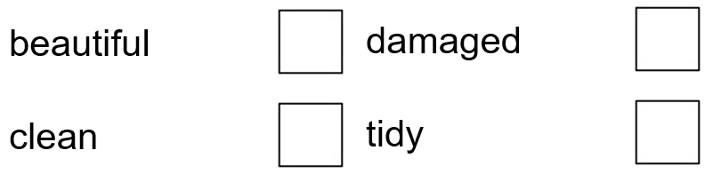

TASK 3 – Inference Questions:
- ‘Sort out the garden, you lazy snorer!’ yelled the fairy, and down came the frying pan’ What do you think has happened to the frying pan at this point in the story?
_________________________________because__________________________________________________________________________________________
_________________________________________________________________

- Look at paragraph 4. It says ‘...the words got stuck in his throat…’ What do you think is meant by this phrase?
_________________________________because__________________________________________________________________________________________
_________________________________________________________________
Do not forget to share your answers with us on ClassDojo.

WRITING Friday 21st January 2022 – Using parenthesis to add extra information
Scan the QR code or follow the link to find out more about parenthesis from the BBC Bitesize website. https://www.bbc.co.uk/bitesize/articles/zhpt7yc

What is parenthesis?
When we're writing, we can add extra words to a sentence to give more information or explanation. If you take the parenthesis away (the extra information) the sentence STILL MAKES SENSE!
We call the extra words that have been added a parenthesis.

We can use three types of punctuation to add parenthesis:
- Pair of Brackets ( )
- Pair of Commas , ,
- Pair of Dashes - -

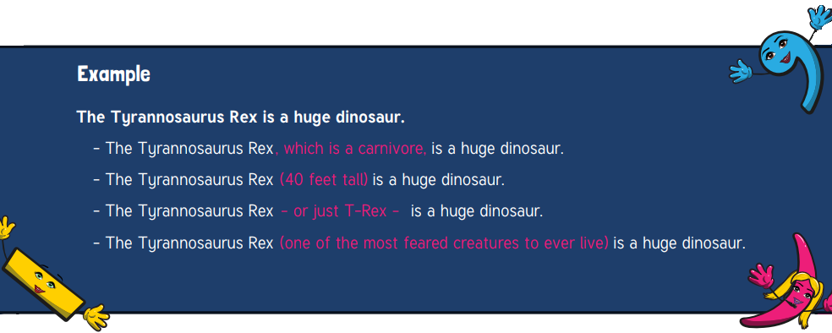

•The daffodil (which has yellow petals) is a plant that grows in the spring time.

•My brother - the one who lives in Australia - is coming to the wedding.

•Year 4 , who are the best in the school, won an amazing prize.

TASK 1: Adding parenthesis punctuation
Read the sentences carefully and add either brackets, commas or dashes around the extra information in these sentences to show parenthesis and underline the extra information. The first one has been done for you.

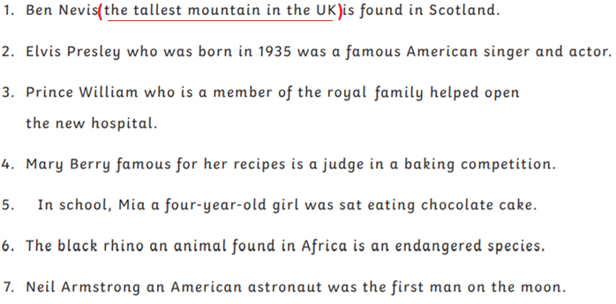

TASK 2:
Take a photograph of your sentences using parenthesis and upload them onto Dojo so that we can share these with the class.

STARTER:
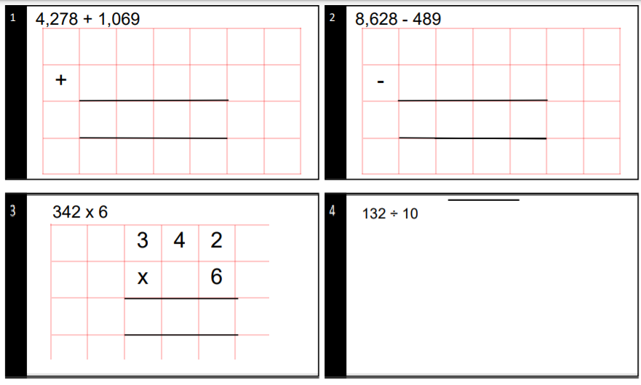

MAIN ACTIVITY:
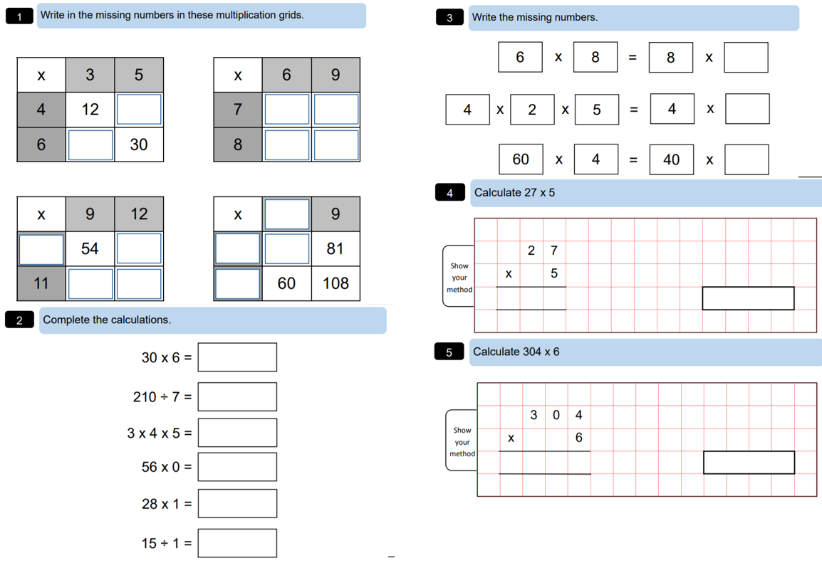

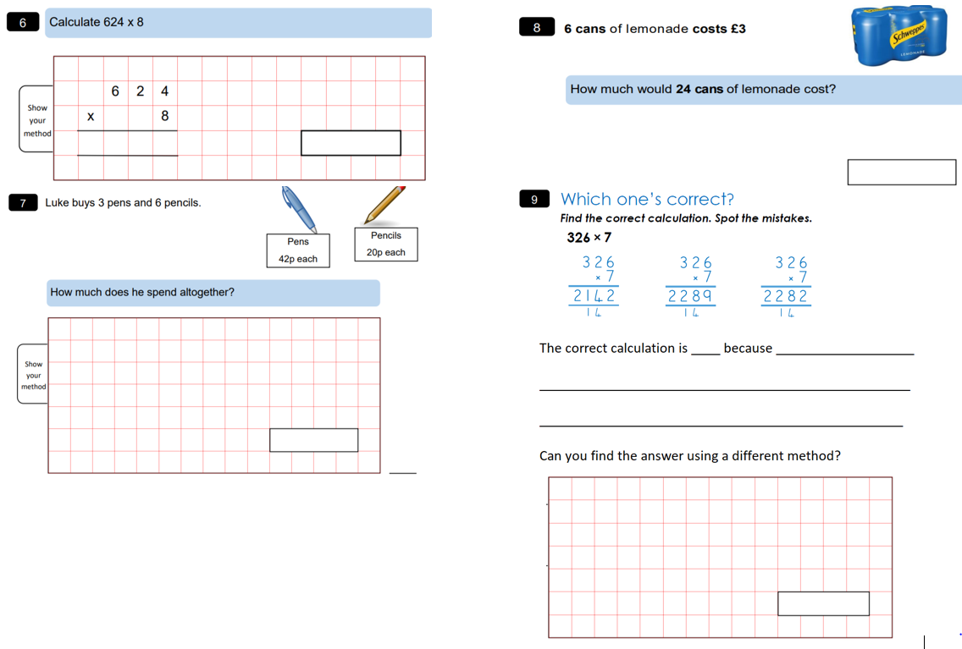

EXTENSION:
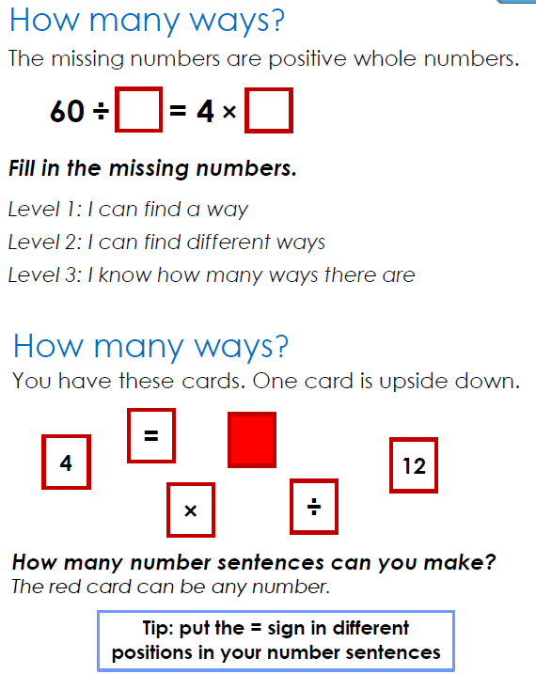

ART /DT Friday 21st January 2022 – Origami Artwork Boats
ORIGAMI
Origami is the art of paper folding, which is often associated with Japanese culture.
Today you will be creating an origami boat and you will need:
- A piece of A4 card / paper
- Patience!
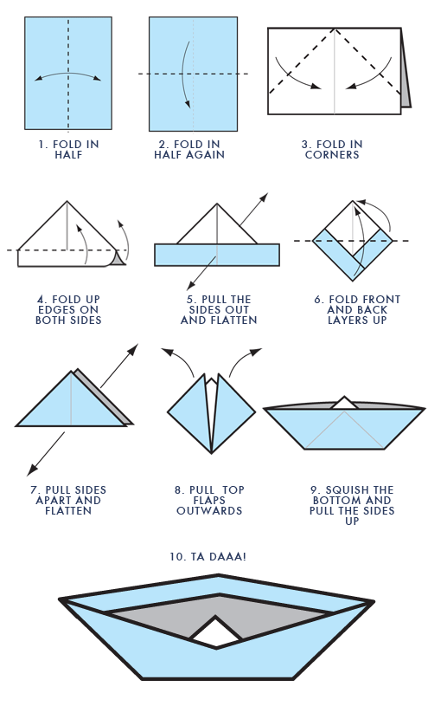
Video Tutorial:
Follow the video tutorial below also to help you and pause throughout:

Share your origami boats with us on class dojo and test them out to see if they float!

Extension:
By following different tutorials, can you create anything else using the art of origami?

PE – Friday 21st January 2022 - Catch and Clap
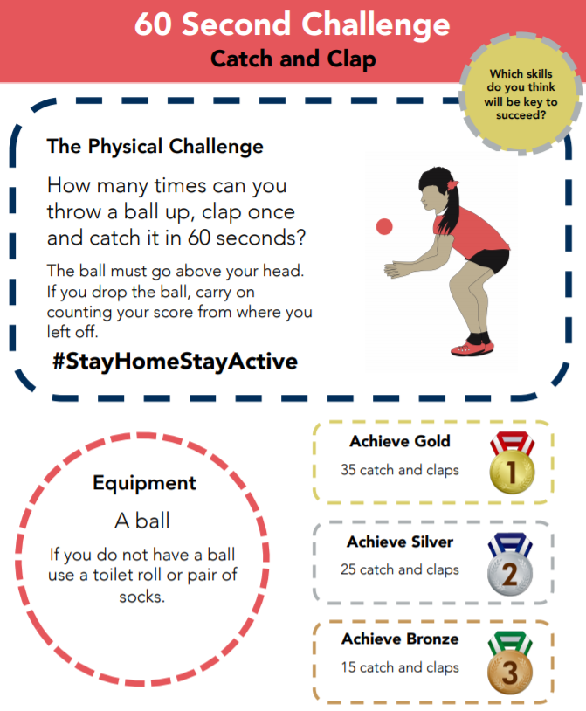

TOP TIP: You can use a pair of socks if you cannot find a ball!
Share some pictures and videos of you completing the challenge and share these with us in ClassDojo and we will see if we have an overall winner for the class!

