Year 6 | Tuesday | Wednesday | Thursday | Friday
9:00-10:00 | Independent practice- Maths | Independent practice- Maths | Independent practice- Maths | Independent practice- Maths
10:00-10:30 | Independent practice- Comprehension | Independent practice- Comprehension | Independent practice- Comprehension | Independent practice- Comprehension
10:30 -11:00 | Reading for pleasure | Reading for pleasure | Reading for pleasure | Reading for pleasure
11.00-11.15 | Break
11.45-12.15 | Independent practice- English | Independent practice- English | Independent practice- English | Independent practice- English
12.15-1.30 | Lunch
1.30-1.45 | Handwriting | Spelling | Handwriting | Individual reading
1:45-2:15 | Geography | Geography | PSHE | PE and Music
2:15-2:45 | Individual reading | Individual reading | Individual reading | Catch ups  Check that you have completed your pack and are ready to start at school next week
2:45-3:00 | Times Table Rockstars | Times Table Rockstars | Times Table Rockstars
Work Pack for Remote Learning: Tuesday 18th January - Friday 21st January 2022

Dear Year 6,
This pack covers four days of work. If you need any support as you are working through this, please send us a dojo and please do remember to share your work with us by dojo – we love to see how you are getting on and being here to help you.
We have been so impressed with your work so far this year and we look forward to the wonderful work that we are sure you will do over the next four days! We will be building on this when you return to school.
Mrs Spencer and Miss Hill

Tuesday 18th January 2022
Maths
WALT: change an improper fraction to a mixed number and vice versa
Starter: Autumn Term: Workout 8 (see sheet at the end of the pack)

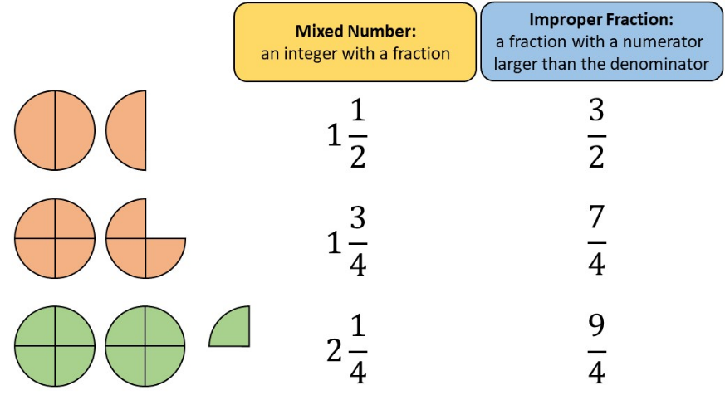
Here is a description of a mixed number and an improper fraction:

Change these improper fractions into mixed numbers:
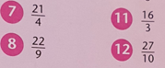
Change these mixed numbers into improper fractions:
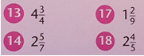

Now challenge yourself with the following SATs questions that will extend your understanding of fractions. Please try as many as possible:
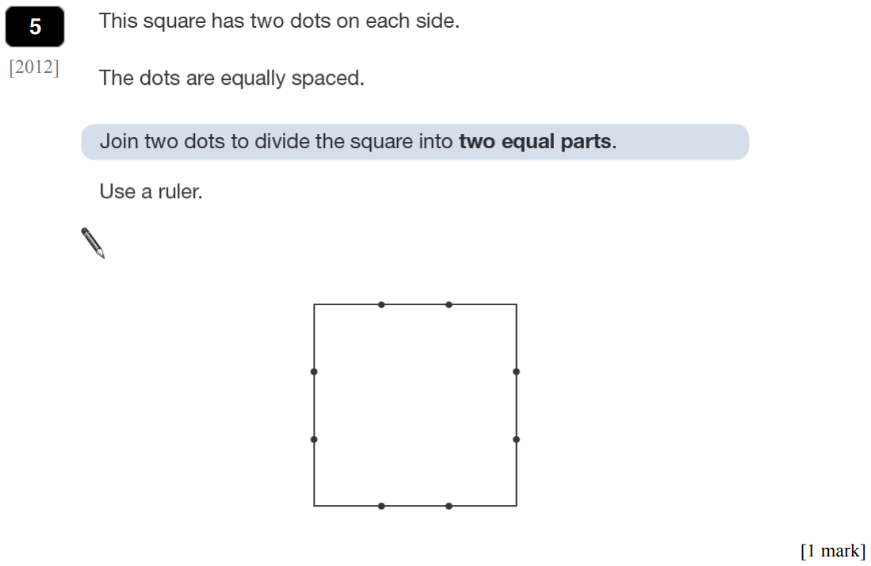

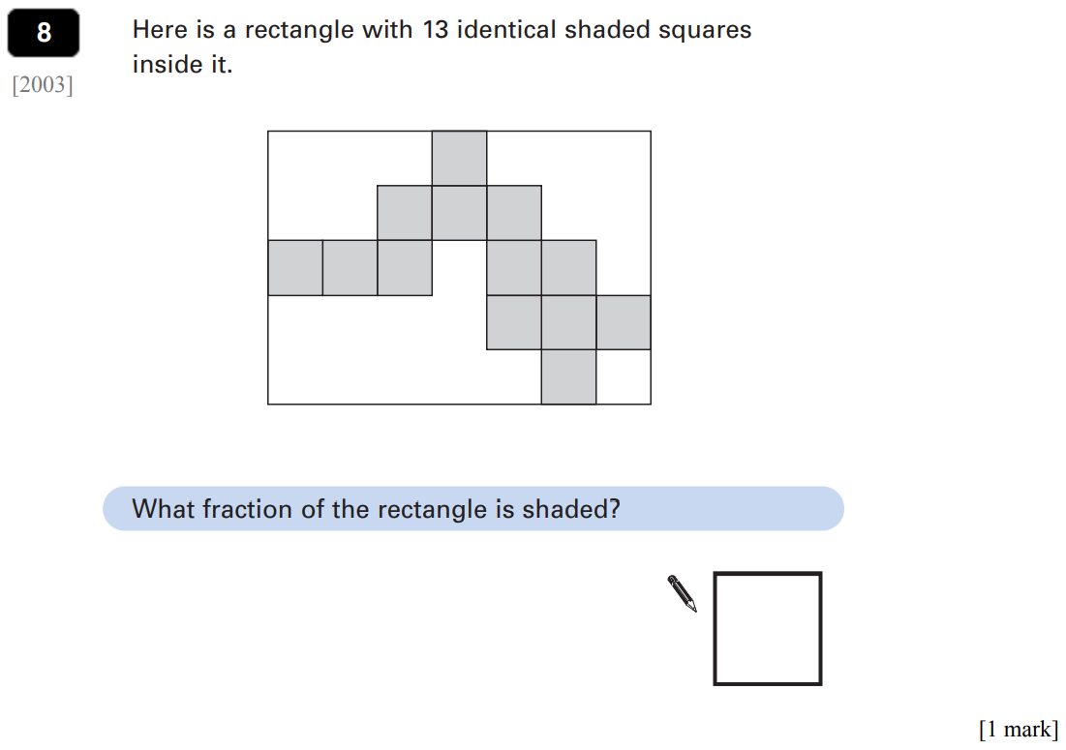
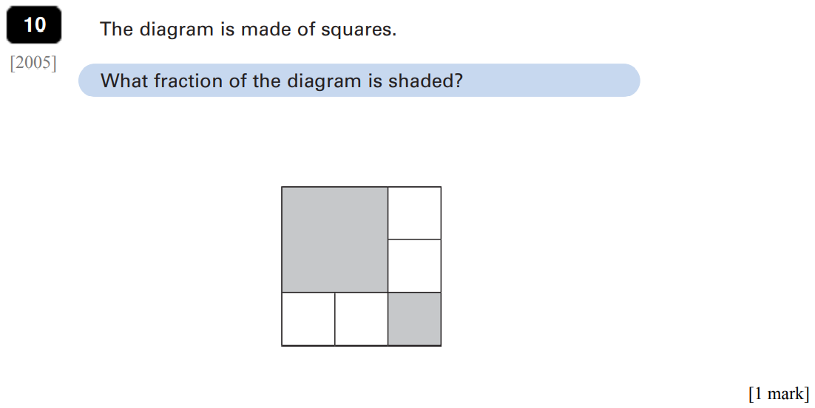

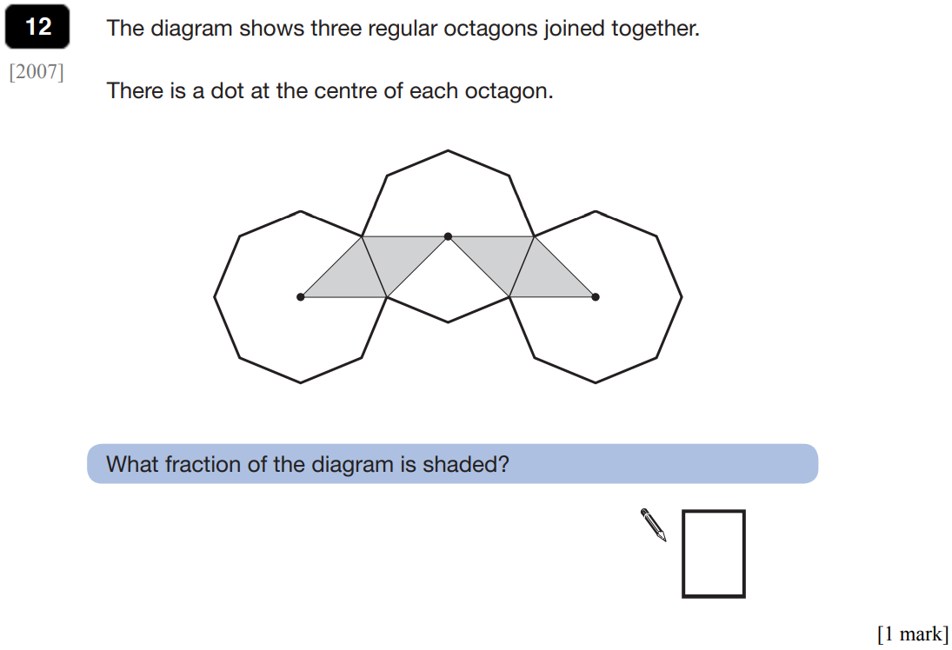
Extension (Miss Fox/Mrs Spencer’s groups): Can you complete the following challenges?
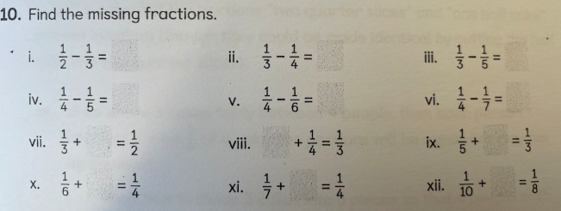
Tuesday 18th January 2022
Comprehension
Read the poem To Asgard at the back of the pack and answer comprehension questions 1- 3 on the page titled ‘Retrieval’. If there are any words you do not know, underline them and look them up in a dictionary, annotating your text with the definitions.
An online dictionary can be found here: https://dictionary.cambridge.org/dictionary/
English
SPAG Modal Verbs:
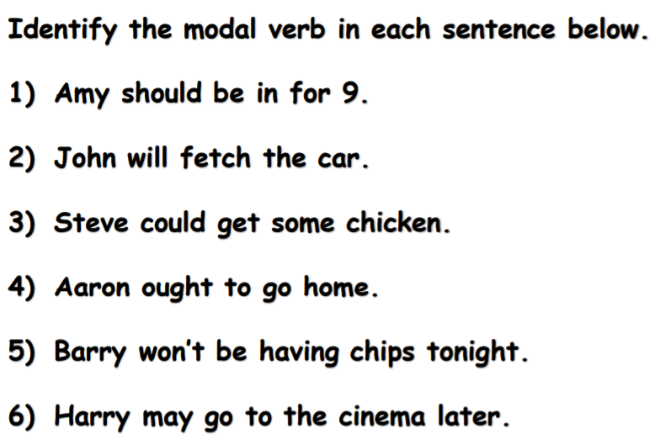

WALT: Analyse the features of a balanced argument

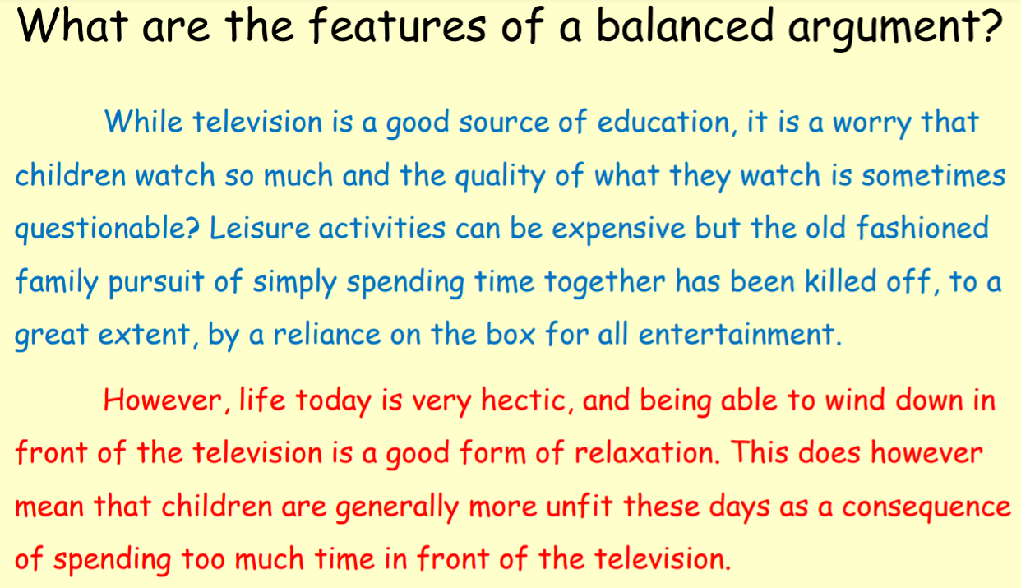

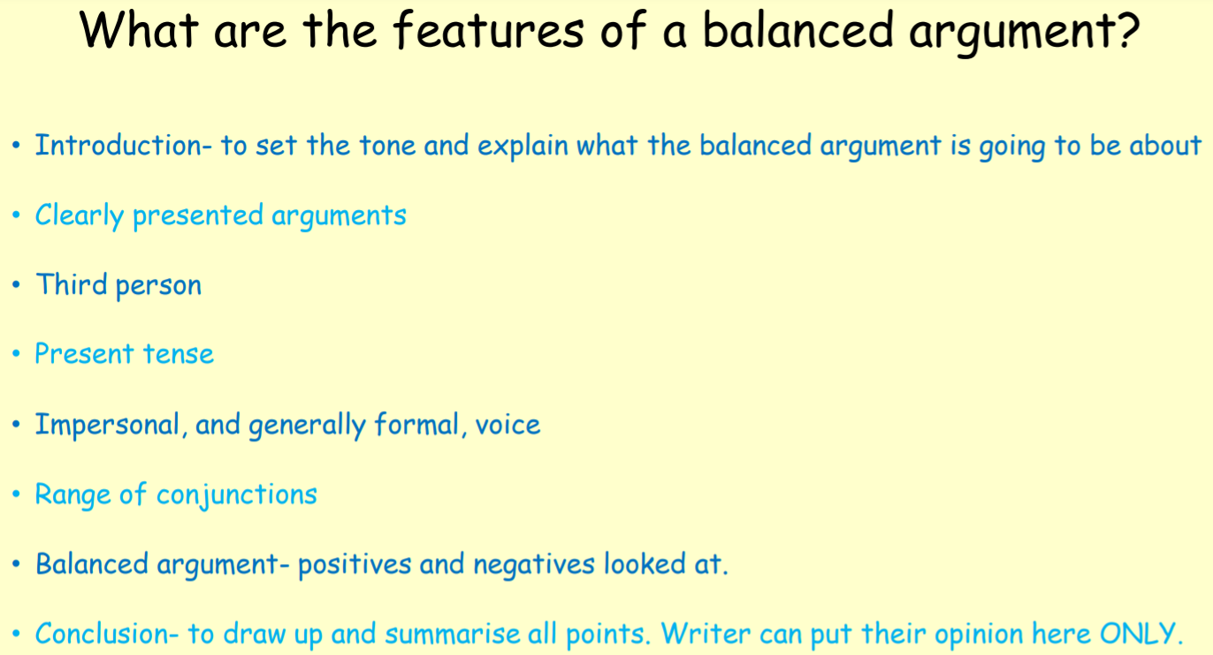

Task: Read the balanced argument below and then give some feedback to the author.
- Which features have they used?
- What are their targets and next steps?

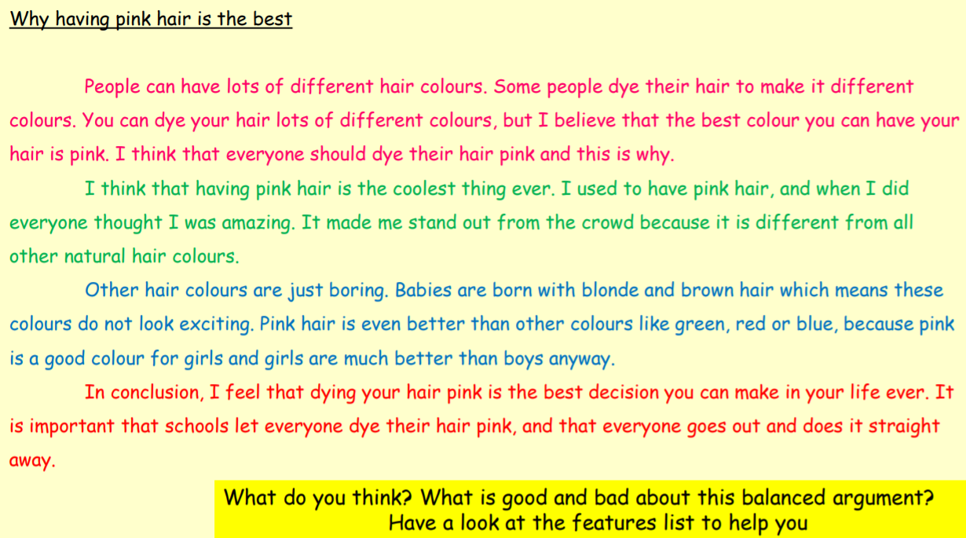

Tuesday 18th January 2022
Handwriting
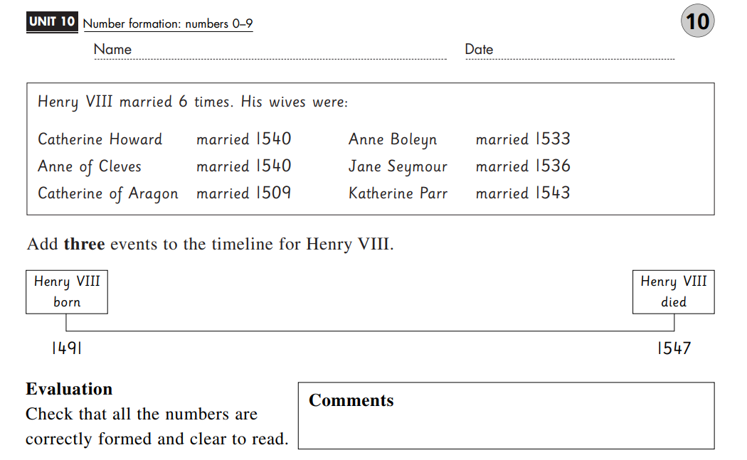

Here is some handwriting paper for any additional practice that you may want to do. Write on the red lines and use the blue lines to focus on the length of your ascenders and descenders.

Tuesday 18th January 2022
Fieldwork: can I create a sketch map of roads in my community?
Scan if you want to watch the video that goes with this learning!
https://classroom.thenational.academy/lessons/fieldwork-can-i-create-a-sketch-map-of-roads-in-my-community-75k3jr

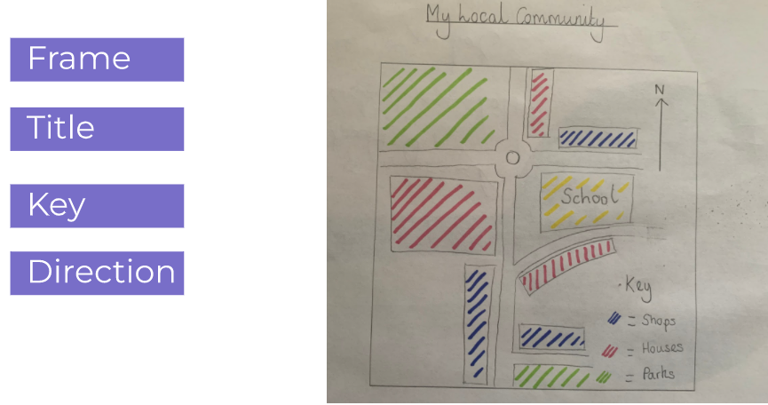
Task: Draw a sketch map.
You can either draw a sketch map from
-one of the satellite images below
-a local walk that you go on
-your own satellite image (you may want to find your house). Use Google Earth:
https://earth.google.com
- Draw a frame
- Add a title
- Draw the roads
- Add the key

Our school
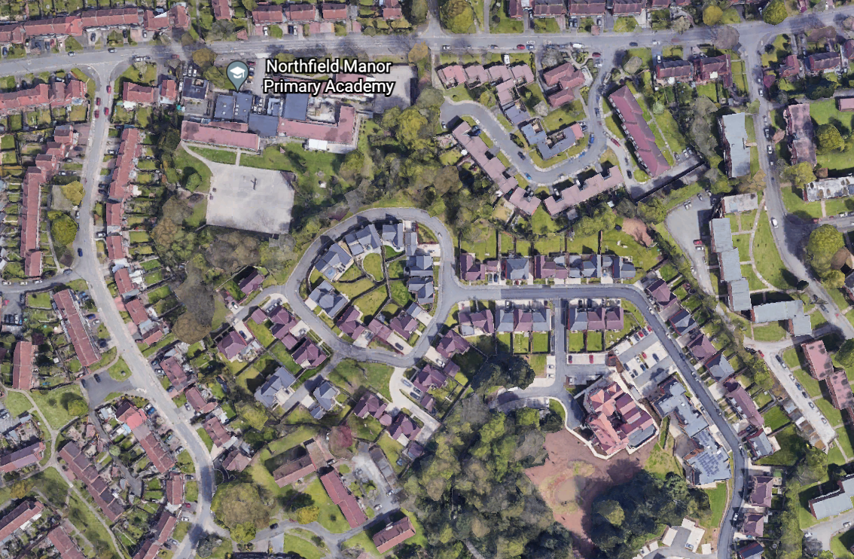Weoley Castle circle
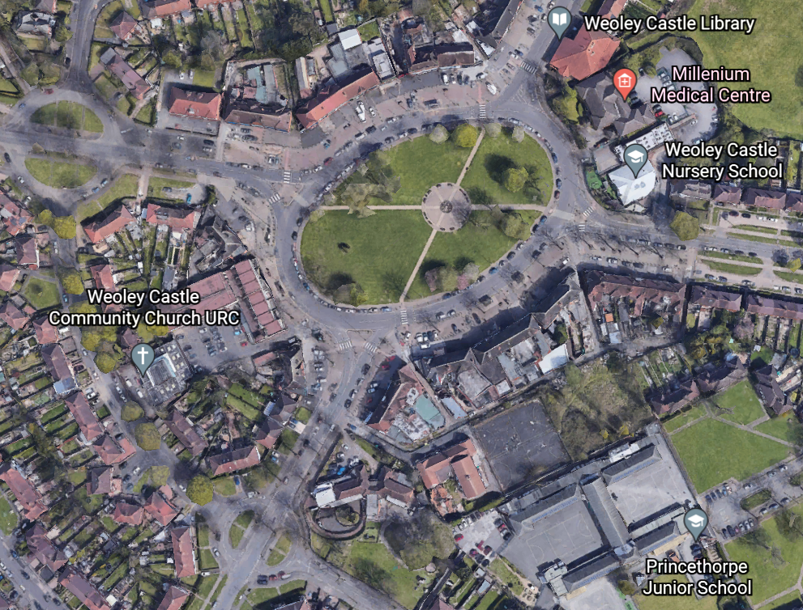

Wednesday 19th January 2022
Maths
Starter: Autumn Term: Workout 9 (see sheet at the end of the pack)
WALT: count using fractions
Choose the level of challenge you want – try to complete all of the questions where you can:
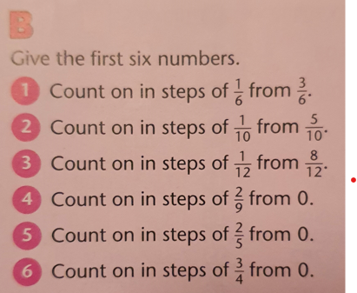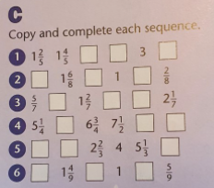
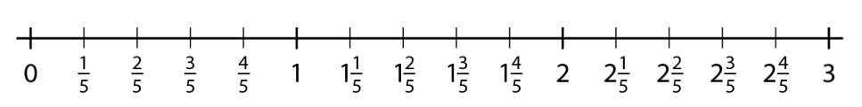
Extension SATs questions:
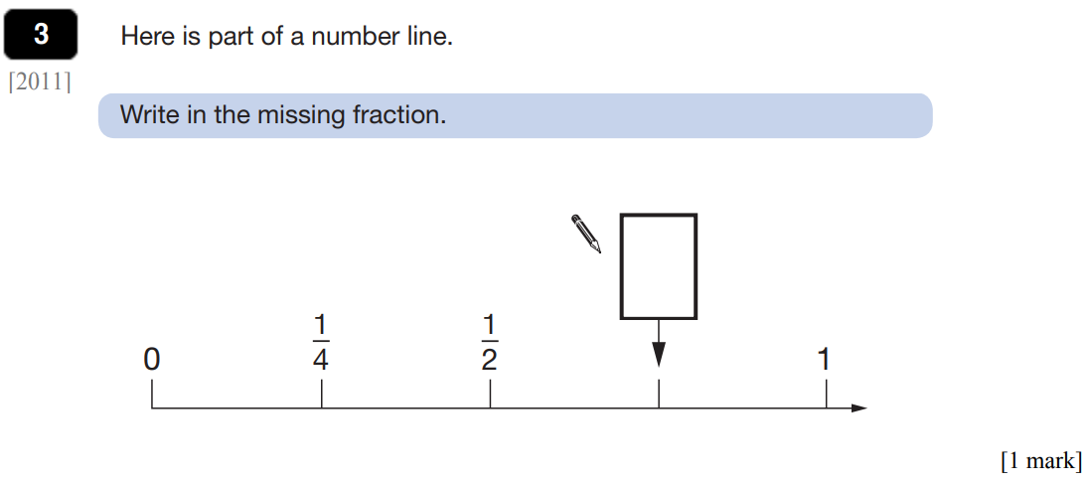
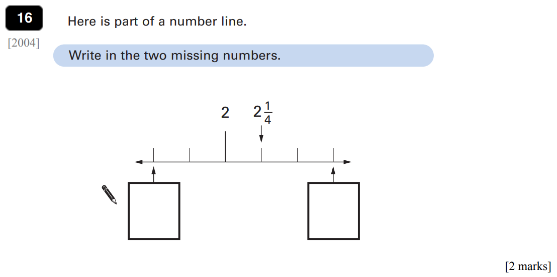

Extension (Miss Fox/Mrs Spencer’s groups): Can you complete the following challenges?
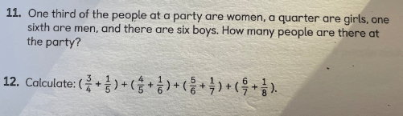

Comprehension
Read the poem To Asgard at the back of the pack and answer comprehension questions 4-5 on the page titled ‘Retrieval’.
Can you recall the words you looked up yesterday – test yourself on their definitions.

Wednesday 19th January 2022
English
SPaG- Modal verbs
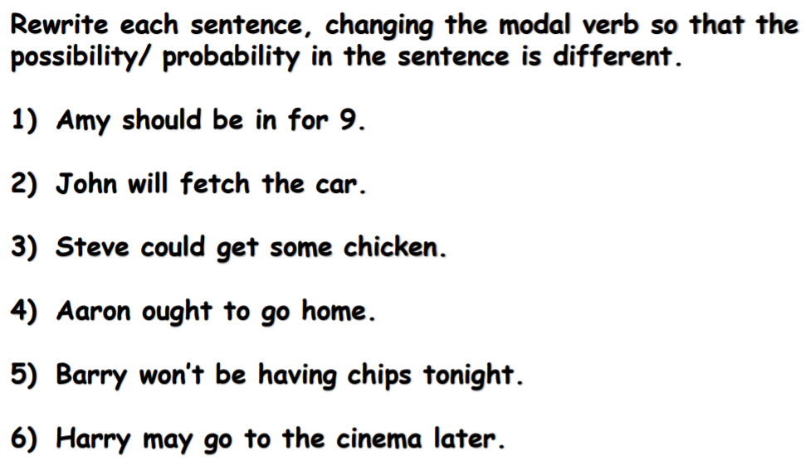

WALT: up level a balanced argument
Today’s task is to re-write the “balanced argument” about pink hair is the best as a balanced argument.
Look at the box in pink below which highlights the improvements that are needed to the paragraphs in blue and green below. Using this information, edit and re-write the two paragraphs to improve them:
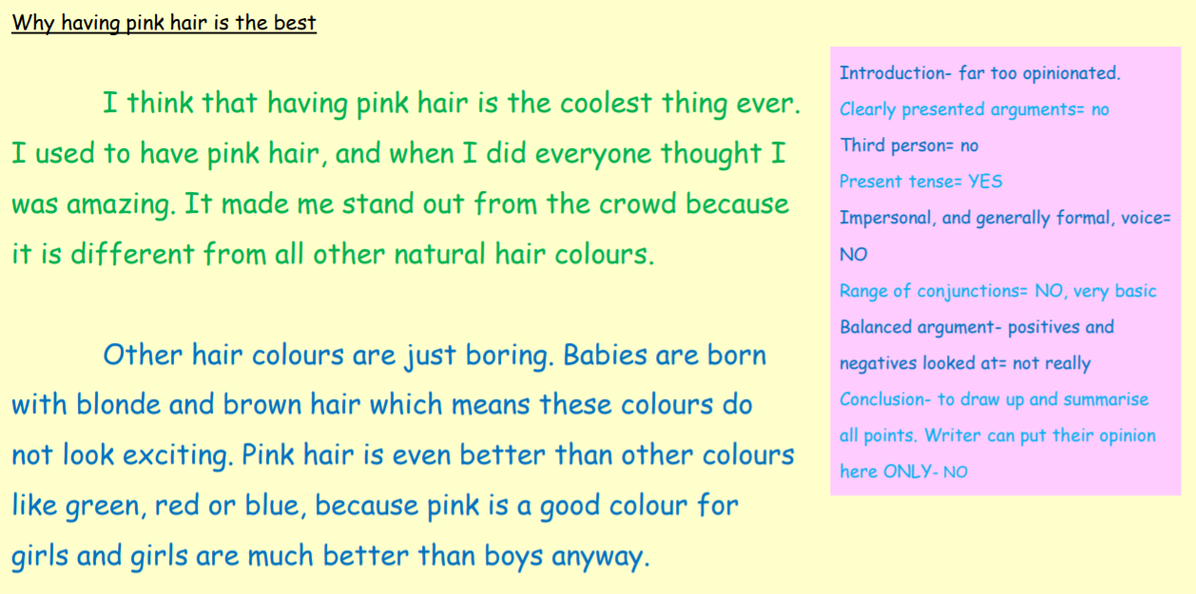

Wednesday 19th January 2022
Spelling
Complete page 10 of your CGP Spelling book – the f sound.

Geography- Tools of fieldwork
https://classroom.thenational.academy/lessons/tools-of-fieldwork-surveys-and-questionnaires-6gwk8c

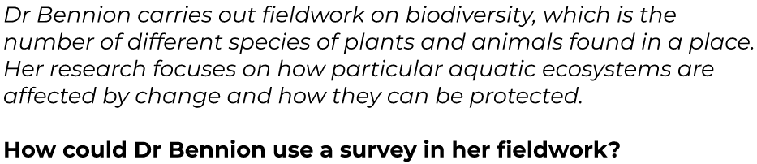
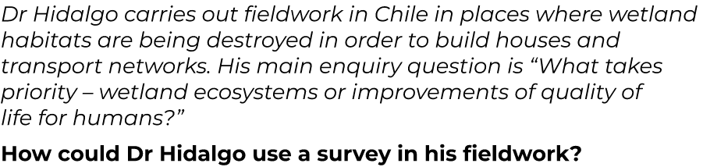
A questionnaire is:
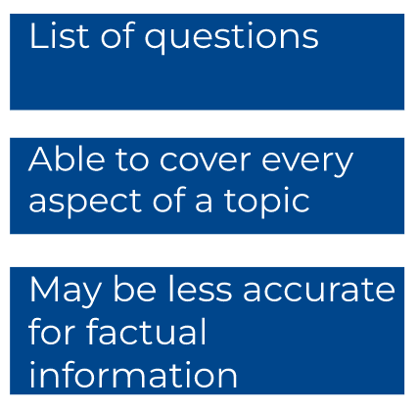
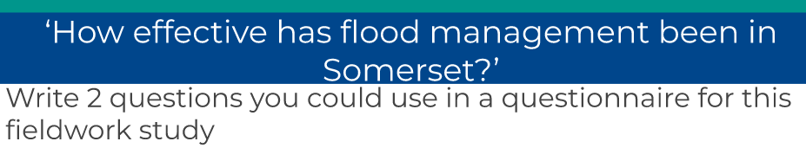
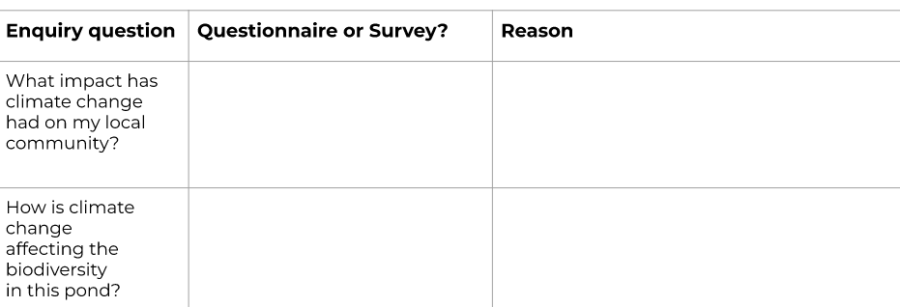

Thursday 20 January 2022
WALT: add and subtract fractions
Starter: Autumn Term: Workout 10
Let’s look at the following rules for adding and subtracting fractions:
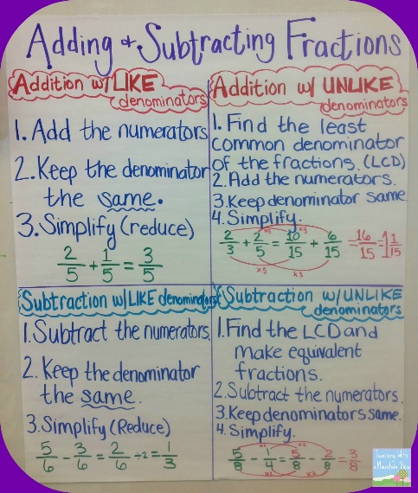

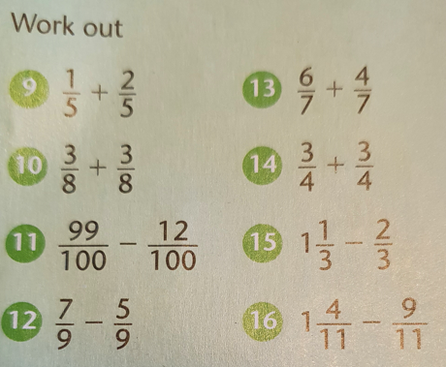
Now, complete as many of the questions below as you can:
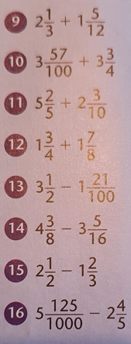

Extension
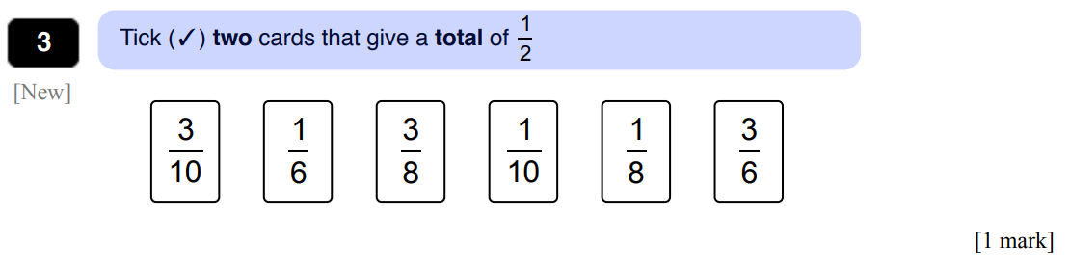

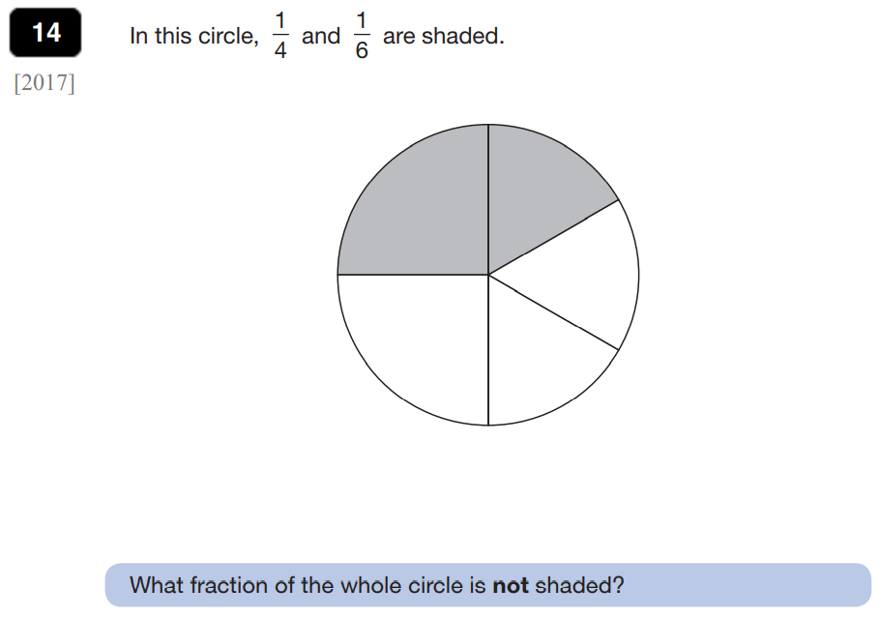

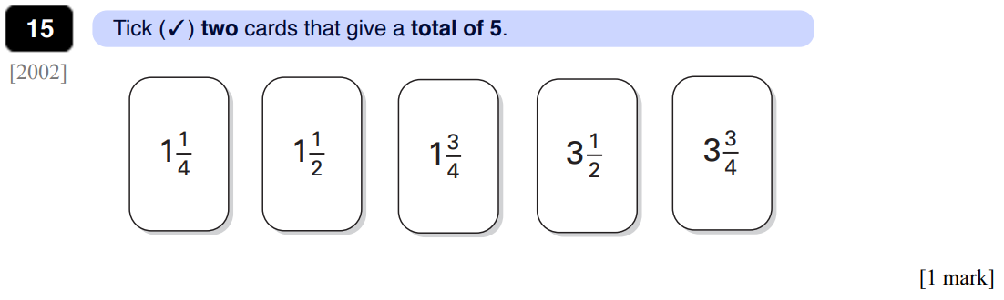
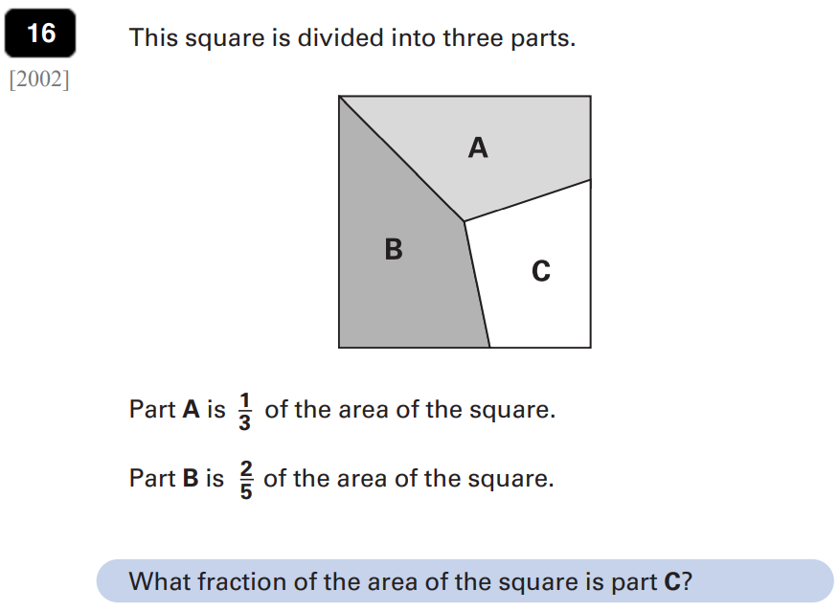
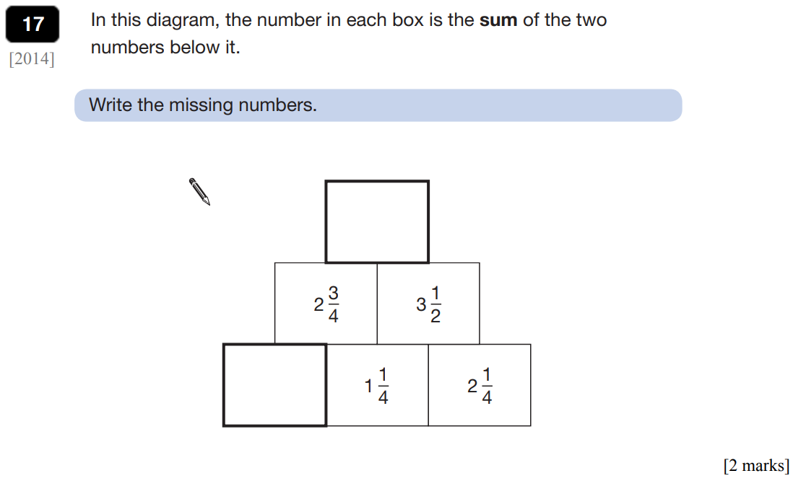

Comprehension
Read the poem To Asgard at the back of the pack and answer comprehension questions 1- 3 on the page titled ‘Mix it Up’. If there are any words you do not know, underline them and look them up in a dictionary. An online dictionary can be found here: https://dictionary.cambridge.org/dictionary/

Thursday 20th January 2022
English
SPaG- Modal verbs
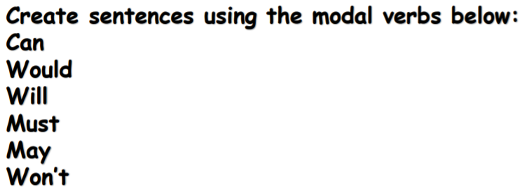
WALT: write one side of a balanced argument
Task 1:
We will be writing a balanced argument on whether mobile phones should be allowed in schools. To prepare for this, sort the quotes below into ones that support mobile phones being used in schools and ones that you think oppose (do not support) the idea.
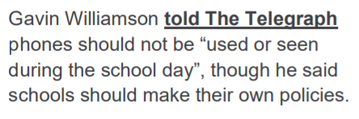
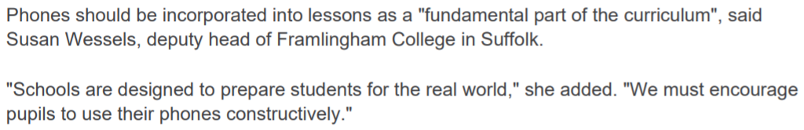
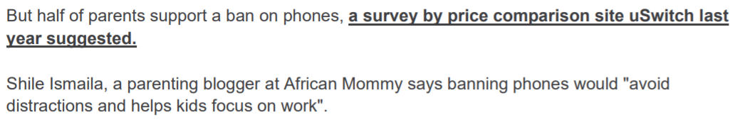
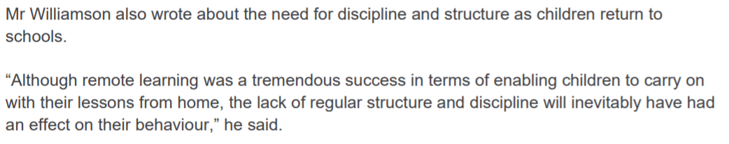
Now, do some research and see if you can find any of your own quotes about mobile phones being allowed in school. Add these to the correct side of your argument.

Task 2:
Choose one side of the argument. Presenting the argument clearly and formally, write a paragraph outlining three of the main points of that side of the argument. Ensure that you include a quote (you can use those you have just sorted above). Make sure that you keep to the facts rather than expressing your opinion at this stage.
Should mobile phones be allowed in schools?
Yes | No
Yes, it should be allowed for the case of emergency.  For parents to get a hold of the child  Mobile phones help communication  They can be used as an educational tool.  If used correctly they can diminish interruptions. | No, because students will be distracted  Camera phones are used to harass students  No, the schools have phones, the students can use those.  They can be used to cheat on tests

Thursday 20th January 2022

Handwriting
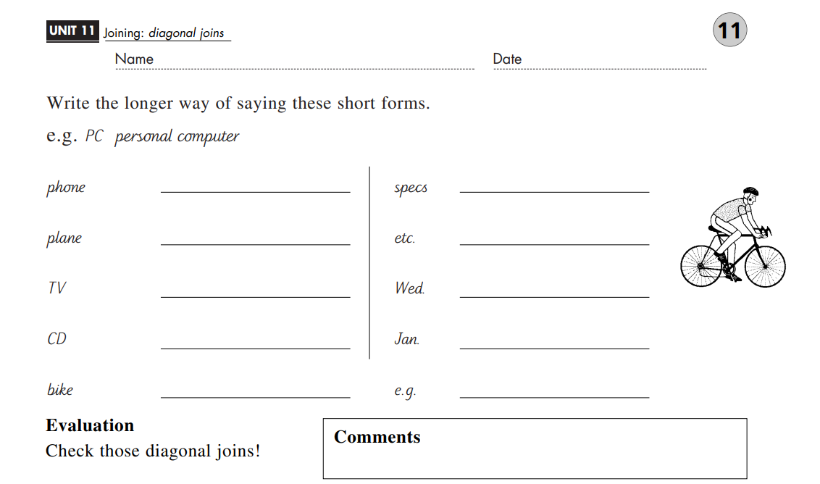
Thursday 20th January 2022

PSHE

WALT: recognise and understand what is meant by a healthy lifestyle

Scan if you want to watch the video that goes with this learning!
https://classroom.thenational.academy/lessons/life-is-all-about-balance-crwk6r

Task: Create a poster to remind you of the main three components of a balanced lifestyle - good food habits, sleep/rest and exercise. There is an example below:

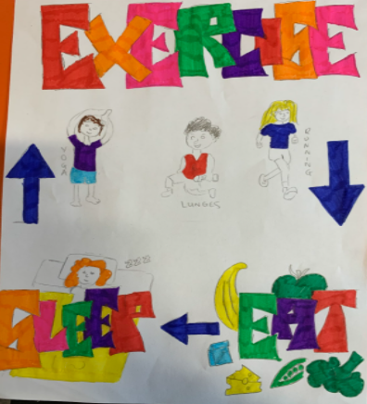

Friday 21 January 2022

Maths
WALT: find a fraction of an amount
If I want to find ¼ of a whole, I would divide the whole by the denominator 4. For example, ¼ of 8 is 8 divided by 4 = 2.
If I want to find ¾ of a whole, I would divide the whole by the denominator 4. For example ¼ of 8 is 8 divided by 4 = 2. As I am now looking for 3 parts not just one, I would then multiple 2 by 3 (because there are 3 parts in ¾) to get 6. 6 is ¾ of 8.

Complete as many of the questions as you can:
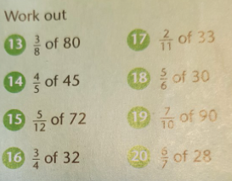

Friday 21 January 2022

Maths Extension
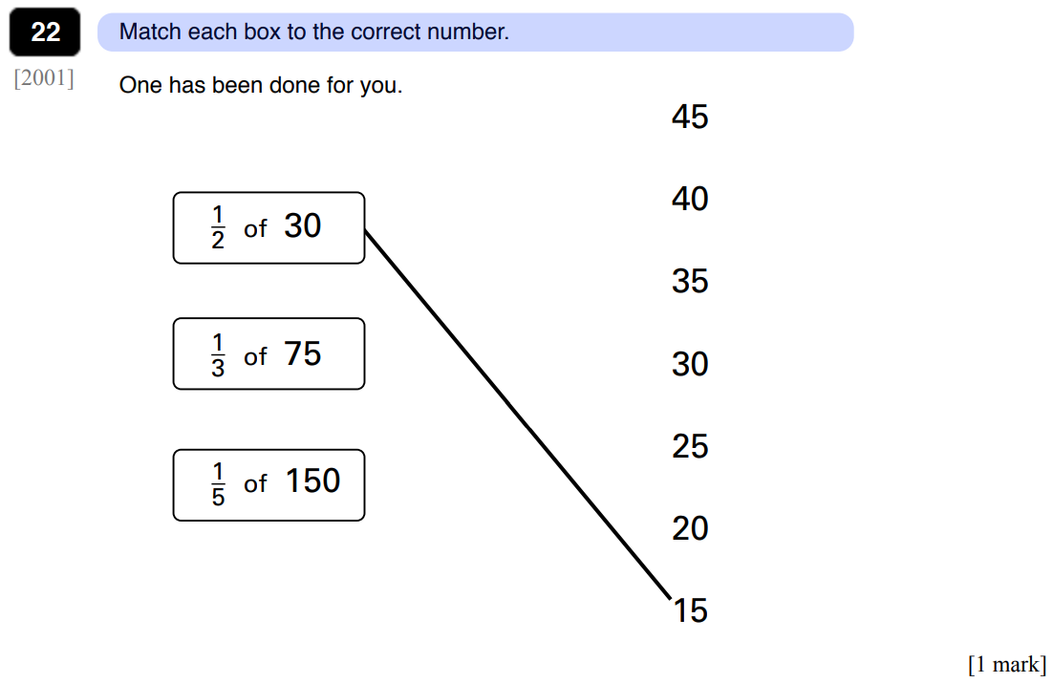
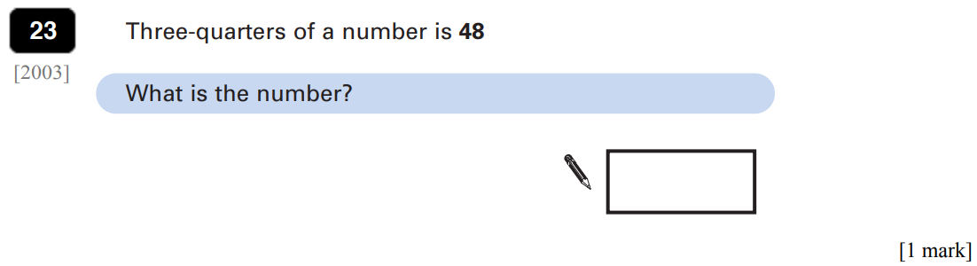
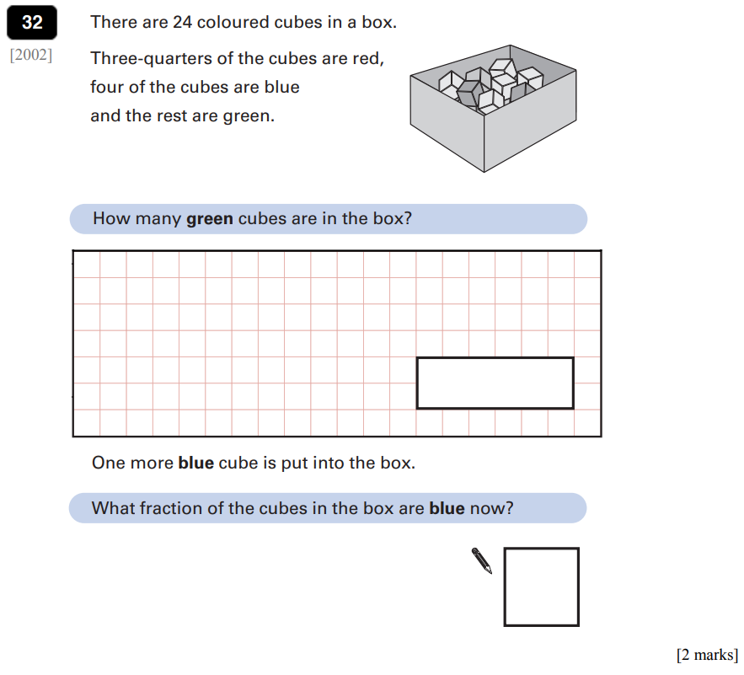

Andy's Marbles
Andy and his friend Sam were walking along the road together. Andy had a big bag of marbles. Unfortunately the bottom of the bag split and all the marbles spilled out. Poor Andy!
One third of the marbles rolled down the slope too quickly for Andy to pick them up. One sixth of all the marbles disappeared into the rain-water drain.
Andy and Sam picked up all they could but half of the marbles that remained nearby were picked up by other children who ran off with them.
Andy counted all the marbles he and Sam had rescued.
He gave one third of these to Sam for helping him pick them up. Andy put his remaining marbles into his pocket. There were 14 of them.
How many marbles were there in Andy's bag before the bottom split?
What fraction of the total number that had been in the bag had he lost or given away?

Friday 21 January 2022
Comprehension
Read the poem To Asgard at the back of the pack and answer comprehension questions 4-5 on the page titled ‘Mix it Up’.
Extension – can you remember all of the words we have looked up from this text. Test yourself. Can you use them to write sentences. For example, can you write sentences using roam, fate, serpent and wily?

English
Your starter today is the crossword below – if you are not sure of the meaning of any of the words please look them up using a dictionary. You could try and create some sentences of your own using these words.
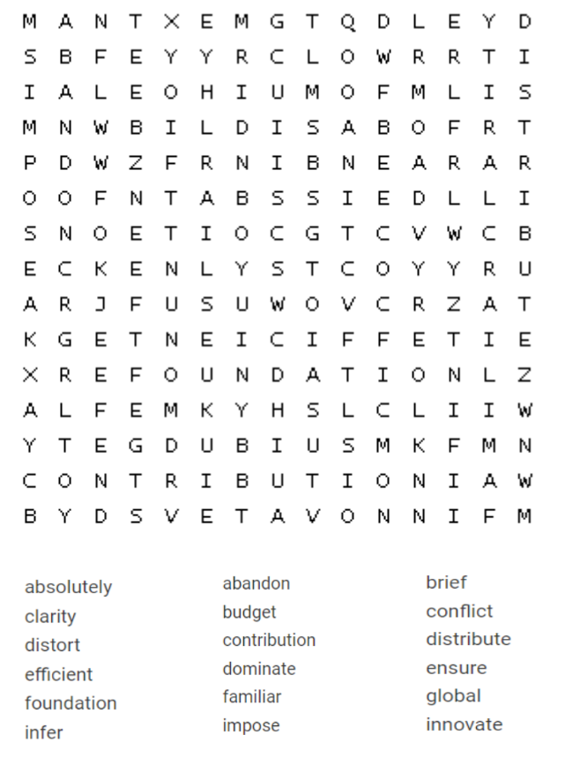
Friday 21st January 2022
WALT: write one side of a balanced argument
Task: Present the points for the opposite point of view.
Yesterday, if you wrote a paragraph about why mobile phones should be allowed in school, today write why they shouldn’t. Likewise, if you wrote about why they shouldn’t yesterday, write about why they should be allowed in school today.
Make sure you have 3 main points and ensure that you include a quote. Also, make sure that you keep to the facts rather than expressing your opinion.

PE- Different types of throw
- The Gear Change game
In big space, find different ways of moving, beginning with walking and jogging, moving into skipping, running.
Use gear numbers for different types of movement and speed.
Gear 1: move slowly by walking
Gear 2: jog
Gear 3: skip
Gear 4: run!
- Fill the square
You need to lay a towel or a sheet flat on the floor about 4 big strides from where you are going to throw from.
You need to throw the balls (one at a time) and try to get them to land on the target.
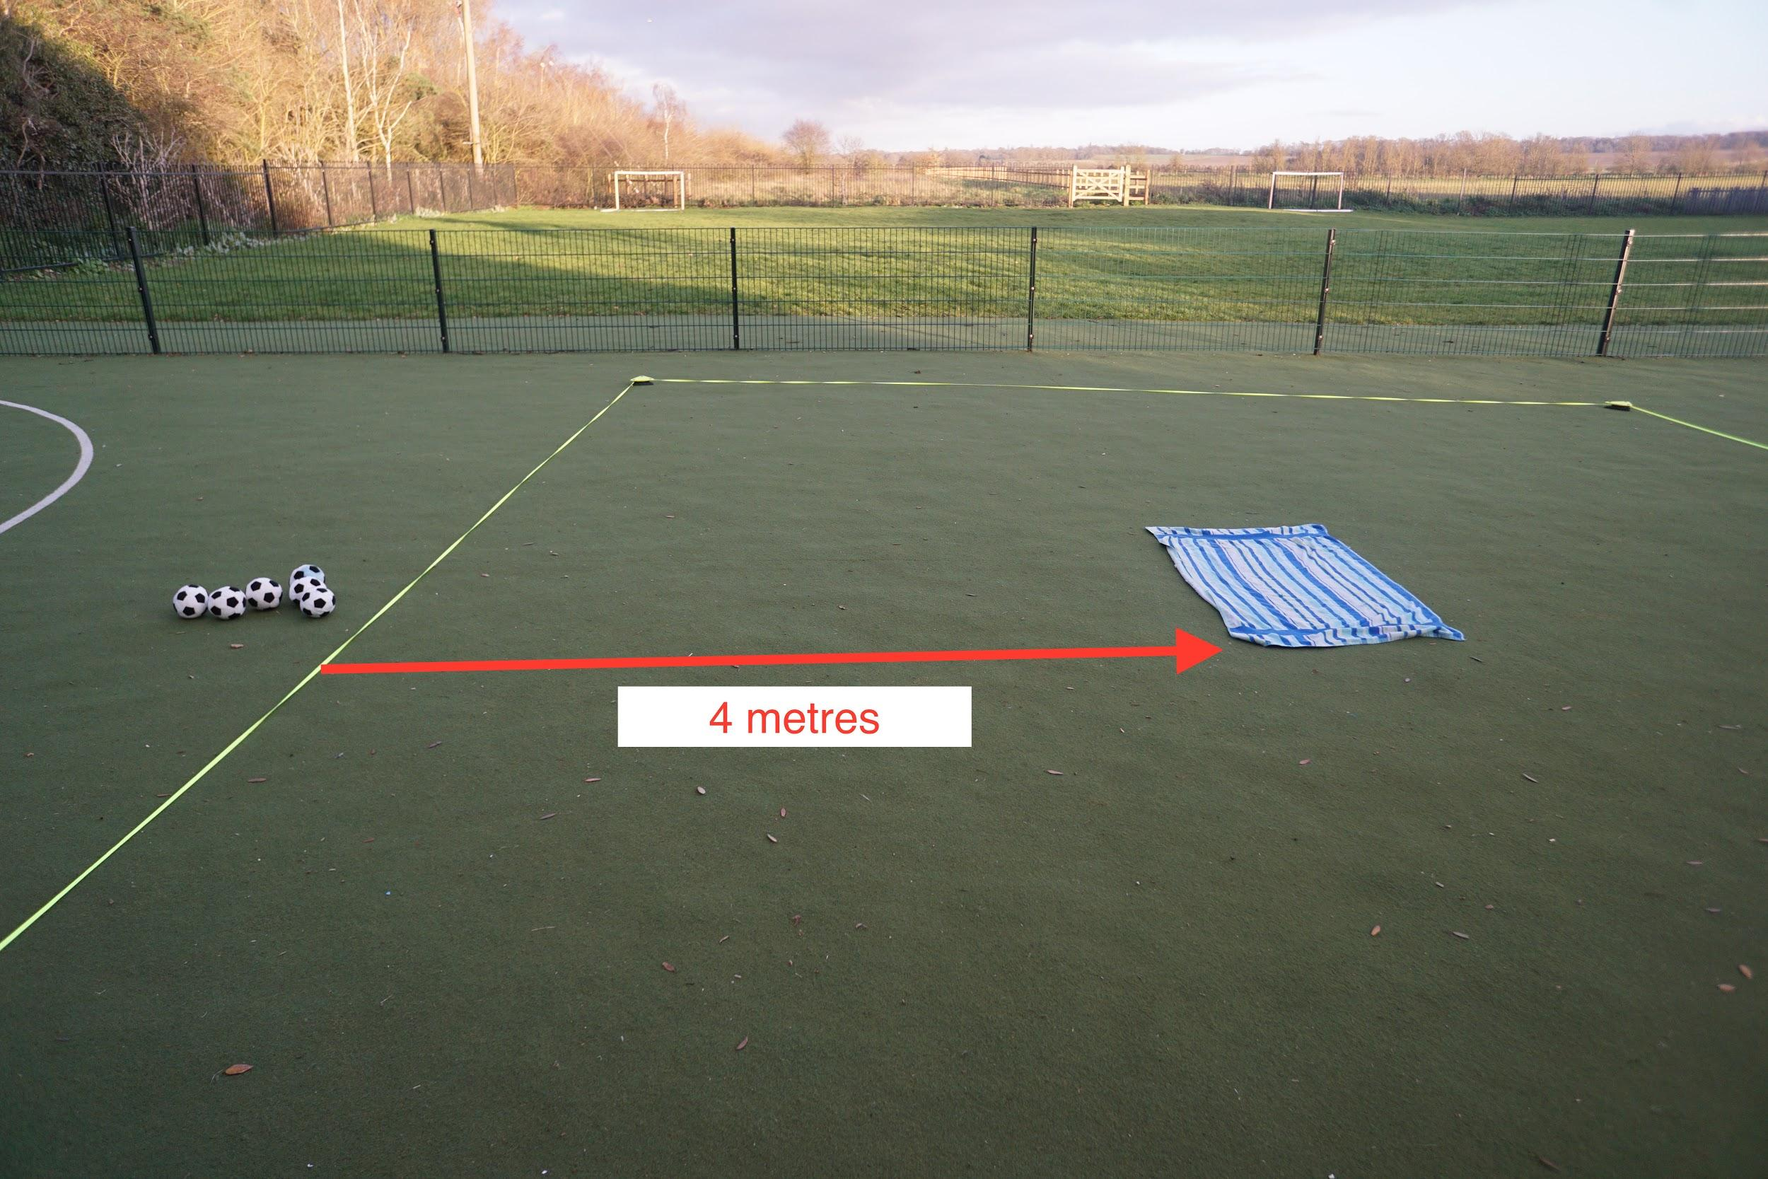
Throw the 6 objects (one at a time) from behind your marker line, and try to get them to all land inside the big target square. After 6 goes, collect up the ones that missed, and do it again. Keep doing this until you can get all 6 into the square.
Try the game using different types of throw
- Under-arm
- Over-arm
- With two hands
- Stretch
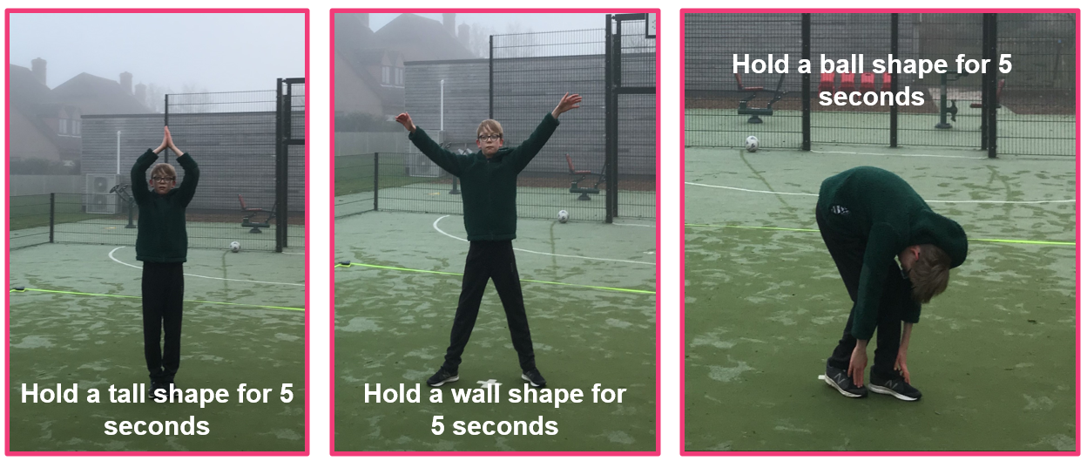

Friday 21st January 2022
Music- Pulse and rhythm
https://classroom.thenational.academy/lessons/understanding-pulse-and-rhythm-6tjkjd

