Happy Friday everyone. Well done for all your hard work this week!
Answers for Thursday 14th May 2020
Maths Starter:
6 x 4 = 24 | 11 x 2 = 22 | 10 x 12 = 120

Main Activity:
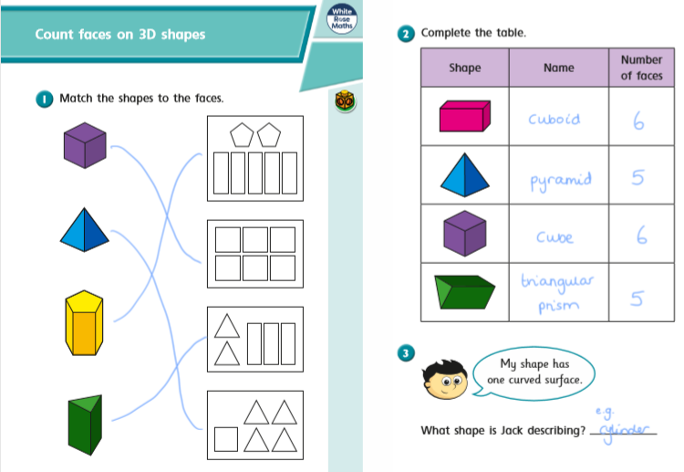
Comprehension
Vocabulary
1. The answer is (c) – walked.
2. ‘Stubbornly’ means being determined not to change one’s mind about something.
3. The word ‘jerked’ is used to describe the wheel moving suddenly.

Retrieval
4. Susie is Cara’s sister.
5. Susie told Cara to shut her eyes if she got scared on the ride.

English- Please send over your child’s descriptive writing for us to read and provide feedback.
Friday 15th May 2020
Maths Starter:
110 ÷ 10 = | 16 ÷ 4 = | 55 ÷ 5 =

Main Activity:
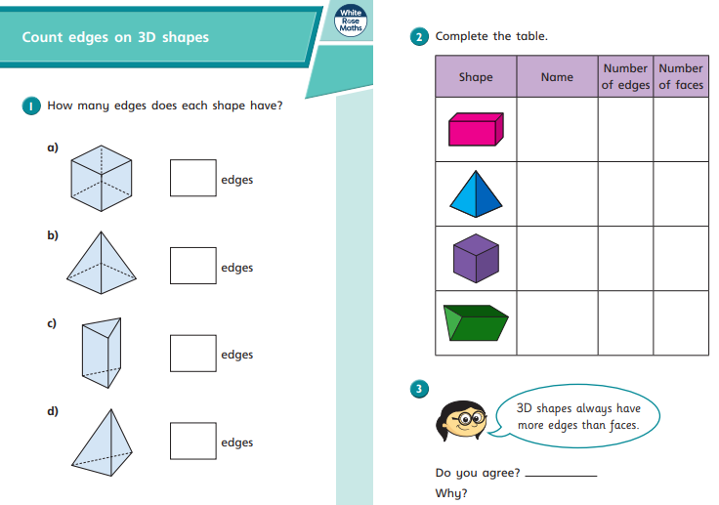

English activity:
The picture is about a special relationship between the two characters. Write a paragraph about a special adult in your life.

Spellings
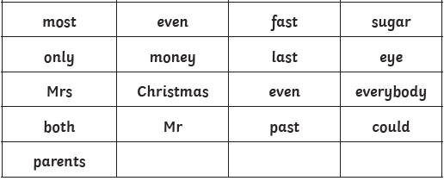
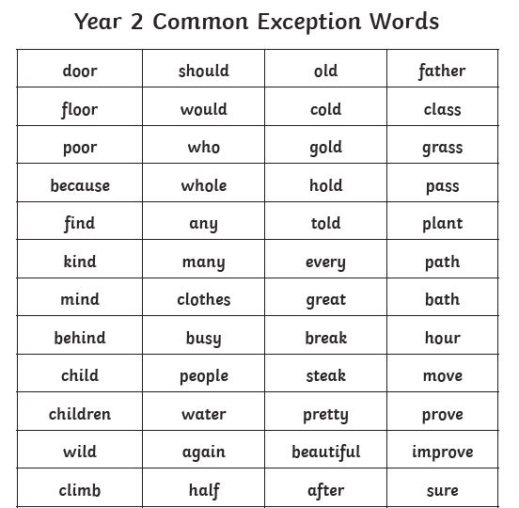

Choose 10 words from the KS1 common exception words to try to learn this week. Practise the same 10 words every day for the week. You may want to be tested on Friday to see how well you’ve learnt them. If you get some wrong, add them to next week’s list and have another go. (Note: The KS1 Common Exception words can be found attached)

