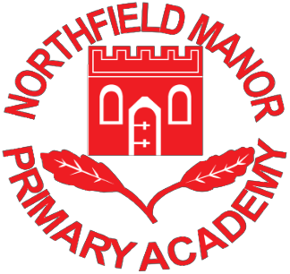

Application for After-School Club Places

Our After-School Club provides a safe and stimulating child-centred environment outside school hours. It runs from 3:20 to 6:00 pm for children in Reception, KS1 and KS2.

Parents/carers are able to leave their children in the knowledge that they will be cared for by qualified and experienced staff who know their children well. A dedicated, experience team of Northfield Manor Academy Staff run the club; between them they are fully trained in all aspects of child-care and supporting teaching from Reception to Year 6. They are also food-hygiene and First Aid trained.

The club is able to access a wide range of facilities; the club uses the KS1 hall; two additional resource rooms; playground; nature area and forest area. The rooms provide quiet and
noisy activities such as reading, homework, craft, interactive white board games, dance, science activities, photography, sports and outdoor play. There will be an opportunity every day for both indoor and outdoor play (weather permitting). Our aim is for the children to have a fun and enjoyable time.
Please see the After-School Club Prospectus for further information including pricing. If you are interested in a place for your child, then please complete the slip below and
return to the office and we will contact you.

---------------------------------------------------------------------------------------------------------

Application for After-School Club place

I wish to confirm my child /children to attend the Northfield Manor Academy After School
Club.

Parent Name: ------------------------------------------------------------------------------------- Child’s Name and Class: ------------------------------------------------------------------------- Child’s Name and Class: -------------------------------------------------------------------------- Please tick the relevant days you wish your child to attend:
Monday Tuesday Wednesday

Thursday Friday

